Background Guide
Nuremberg Trials

Dear Lawyers of the Nuremberg Trials,
Welcome to the Shri MUN 2017!
You should feel extremely lucky and proud to have been selected for the first trial simulation to be in held in Shri MUN ever!
We, as part of the Executive Board, will do our best to make this an incredibly enriching and fun simulation for you. You have the good fortune of being a part of a historical trial simulation which is an extremely rare committee, so make the best of this opportunity and give it your all.
Before you start researching and getting to know more about the trials and the individuals whose trials you will be participating in, we feel that it is important that you get a good understanding of the simulation itself.
This is not a conventional committee, in fact, it is not a committee at all—it is a trial. You will not be delegates, you will be lawyers. Half of you will be prosecutors whose goal will be to find evidence and convict the defendants of the crimes they are charged of. The other half will be defense attorneys who will have to find evidence to defend their clients and try to free them of the charges against them.
The trial will take place in two stages:

1. The Submission of Evidence: In this stage, you will have to put forward the evidence you have found and want to use in the trial. Both sides will be expected to provide evidence and it is imperative that you all are prepared and well researched for the process.

2. Opening Statements and Rebuttals: In this stage, first the prosecution and then the defense will make opening statements and provide rebuttals in which you will put forth your case and try to convince the judges that they should give a verdict in favor of your case.

Remember that the simulation is only as good as the people participating in it, so if you work hard and do your best, you will ensure that this simulation will be a roaring success!
If you have any doubts or queries, please do not hesitate to contact us.
Warm Regards,

Milind M. Singh Jessy Jindal Sandli Pandey
Chair Vice Chair Vice Chair
milindmsingh@gmail.com jessyjindal@gmail.com sandlipandey@yahoo.com

The background guide includes a brief summary of the Holocaust and the treatment of Jews at the hands of the Germans, highlighting the atrocities and war crimes committed by the Third Reich. Following this necessary background information, the guide includes a case specific profile of each of the defendants, the crimes he is accused of and the actions undertaken by the defendant during the Second World War. The guide also includes an introduction to the Nuremberg Trials and will provide the delegates with all the necessary information they need about the trials. Following this information, we have a brief layout of how the trial will proceed as well as a to do list for delegates to base their reasearch on.
WHAT WAS THE HOLOCAUST?
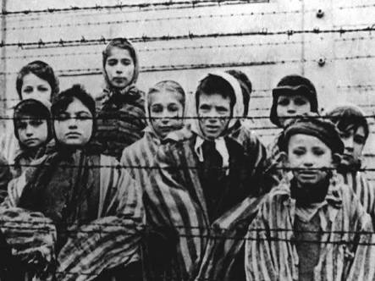
The Holocaust was the systematic, state-sponsored persecution and murder of six million Jews by the Nazi regime and its supporters as part of the "Final Solution”. Holocaust is a word of Greek origin meaning "sacrifice by fire." The Nazis, who came to power in Germany in January 1933, believed that Germans were "racially superior" and that the Jews, deemed "inferior," were an alien threat to the so-called German racial community.
As Nazi tyranny spread across Europe, the Germans and their collaborators persecuted and murdered millions of other groups due to perceived inferiority or political and religious dissent. Between two and three million Soviet prisoners of war were murdered or died of starvation, disease, neglect, or maltreatment. The Germans targeted the non-Jewish Polish intelligentsia for killing, and deported millions of Polish and Soviet civilians for forced labor in Germany or in occupied Poland, where these individuals worked and often died under deplorable conditions.
From the earliest years of the Nazi regime, German authorities persecuted homosexuals and others whose behavior did not match prescribed social norms. German police officials targeted thousands of political opponents (including Communists, Socialists, and trade unionists) and religious dissidents (such as Jehovah's Witnesses). Many of these individuals died as a result of incarceration and maltreatment.
To concentrate and monitor the Jewish population as well as to facilitate later deportation of the Jews, the Germans and their collaborators created ghettos, transit camps, and forced-labor camps for Jews during the war years. The German authorities also established numerous forced-labor camps, both in the so-called Greater German Reich and in German-occupied territory, for non-Jews whose labor the Germans sought to exploit.
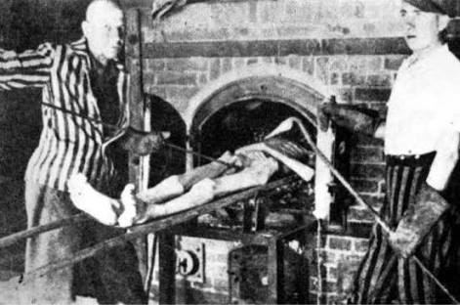
Following the invasion of the Soviet Union in June 1941, Einsatzgruppen (mobile killing units) and, later, militarized battalions of Order Police officials, moved behind German lines to carry out mass-murder operations against Jews, Roma, and Soviet state and Communist Party officials. German SS and police units, supported by units of the Wehrmacht and the Waffen SS, murdered more than a million Jewish men, women, and children, and hundreds of thousands of others.
Between 1941 and 1944, Nazi German authorities deported millions of Jews from Germany, from occupied territories, and from the countries of many of its Axis allies to ghettos and to killing centers, often called extermination camps, where they were murdered in specially developed gassing facilities.
THE END OF THE HOLOCAUST
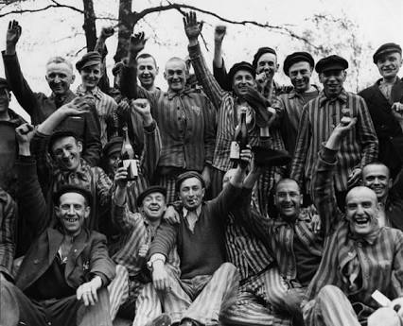
In the final months of the war, SS guards moved camp inmates by train or on forced marches, often called “death marches,” in an attempt to prevent the Allied liberation of large numbers of prisoners. As Allied forces moved across Europe in a series of offensives against Germany, they began to encounter and liberate concentration camp prisoners, as well as prisoners en route by forced march from one camp to another. The marches continued until May 7, 1945, the day the German armed forces surrendered unconditionally to the Allies.
For the western Allies, World War II officially ended in Europe on the next day, May 8 (V-E Day), while Soviet forces announced their “Victory Day” on May 9, 1945.
In the aftermath of the Holocaust, many of the survivors found shelter in displaced persons (DP) camps administered by the Allied powers. Between 1948 and 1951, almost 700,000 Jews emigrated to Israel, including 136,000 Jewish displaced persons from Europe. Other Jewish DPs emigrated to the United States and other nations. The last DP camp closed in 1957.

INTERNATIONAL JUSTICE BEFORE NUREMBERG
At the Paris Peace Conference in 1919, the delegates of 10 Allied Powers ratified the Commission of Responsibilities at a plenary session of the committee in January. (The five major powers Britain, the USA, France, Italy, and Japan were joined by Yugoslavia, Romania, Greece, Poland, and Belgium) The Commission was created for the purpose of determining the facts surrounding:
1) the “responsibility of the 7 authors of the war,”
2) the “facts as to the breaches of the laws and customs of the war committed by the forces of the German Empire,”
3) the degree to which those culpable were responsible for their offences, and
4) the “constitution and procedure of a tribunal appropriate for the trial of these offences.” The Commission’s legacy is one of significantly altering discourse and thought on the proper handling of war crimes cases.
On the Commission’s recommendations, the Treaty of Versailles provided for German officials to be arrested and tried as war criminals. In 1921, trials were to take place on an international tribunal with five judges, one from each of the Great Powers of the day. However, adopting the Commission’s policies in the Treaty is the closest international leaders got to instituting international criminal justice. Germany refused to extradite any of the roughly 900 criminals named by the Allies as war criminal suspects so they could be tried; the Dutch were equally unwilling to extradite the former Kaiser for fear of violating neutrality. Ultimately only 12 criminals were tried in the Lepzig War Crimes Trials, out of which half were found not guilty and half received extremely lenient sentences.

Three officials of the Kharkov Gestapo were tried before a Soviet military court in Kharkov, Ukraine in December of 1943. This was the first trial of Nazis or Nazi collaborators before any court.

CONTEXT FOR TRIALS
On 1 November 1943, the Soviet Union, the United Kingdom and the United States published their "Declaration on German Atrocities in Occupied Europe", which gave a "full warning" that, when the Nazis were defeated, the Allies would "pursue them to the uttermost ends of the earth ... in order that justice may be done. ... The above declaration is without prejudice to the case of the major war criminals whose offences have no particular geographical location and who will be punished by a joint decision of the Government of the Allies."

The plan for the "Trial of European War Criminals" was drafted by Secretary of War Henry L. Stimson and the War Department. Following Roosevelt's death in April 1945, the new president, Harry S. Truman, gave strong approval for a judicial process. After a series of negotiations between Britain, the US, Soviet Union and France, details of the trial were worked out. The trials were to commence on 20 November 1945, in the Bavarian city of Nuremberg.

“The Agreement for the prosecution and punishment of the major war criminals of the European Axis” and the annexed Charter, known as the London Charter or Nuremberg Charter, were signed by the four Allied victors (France, the Soviet Union, the United Kingdom, and the United States) on 8 August 1945. The Agreement and Charter were subsequently ratified by 19 other Allied states.

NUREMBERG TRIALS
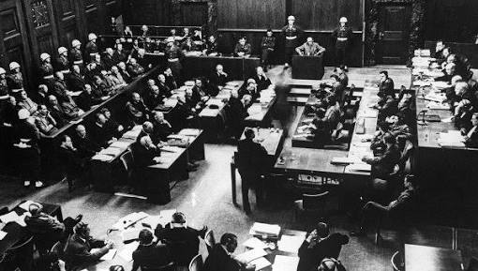
These were a series of trials held in the German city of Nuremberg, that revolutionized international law and were the first example of the principles of justice being implemented and followed on an international scale.

The first, and best known of these trials, was the trial of 24 of the most important political and military leaders of the Nazi Party before the International Military Tribunal. The Tribunal was composed of the following permanent judges: Geoffrey Lawrence, the United Kingdom, Francis Biddle, United States, Henri Donnedieu de Vabres, France, and Iona Nikitchenko, Soviet Union. Each of them had a substitute judge. The chief prosecutors were Robert H. Jackson the Supreme Court Justice of USA, Attorney General Sir Hartley Shawcross of the UK, Lieutenant-General Roman Andreyevich Rudenko of the Soviet Union and Auguste Champetier de Ribes of France.
Assisting Jackson were the lawyers Telford Taylor,^{[22]} William S. Kaplan^{[23]} and Thomas J. Dodd, and Richard Sonnenfeldt, a US Armyinterpreter. Assisting Shawcross were Major Sir David Maxwell-Fyfe and Sir John Wheeler-Bennett.
The vast majority of the defense attorneys were German lawyers.

Around 200 German war crimes defendants were tried at Nuremberg, and 1,600 others were tried under the traditional channels of military justice. Because the court was limited to violations of the laws of war, it did not have jurisdiction over crimes that took place before the outbreak of war on 1 September 1939.

All those being tried at the Nuremburg Trials are answering for offences in one or more of 4 different categories. Those for categories are:
(1) crimes against peace, that is, the planning and waging of wars that violated international treaties;
(2) crimes against humanity, that is, the deportation, extermination, and genocide of various populations;
(3) war crimes, that is, those activities that violated the “rules” of war that had been laid down in light of the First World War and later international agreements; and
(4) conspiracy to commit any and all of the crimes listed in the first three counts.

These crimes were specifically enumerated just prior to the convening of this committee – after much debate they had all been defined in article 6 of the London Charter of the International Military Tribunal-http://www.un.org/en/genocideprevention/documents/atrocity-crimes/Doc.2_Charter%20of%20IMT%201945.pdf
(informally the Nuremburg Charter)

The influence of the Trial can be traced to the foundation of latter-day international criminal courts and the United Nations Charter of Human Rights. These 4 categories of crime have now become a part of international humanitarian law formed in the Geneva Conventions of 1949. Today, these laws seek to limit the effects of armed conflict. It protects persons who are not or are no longer participating in the hostilities and restricts the means and methods of warfare. International humanitarian law is also known as the law of war or the law of armed conflict.

Thus, the committee is charged with trying defendants for their involvement in criminal actions under these 4 categories specifically.

CASE PROFILES
- Hermann Goering
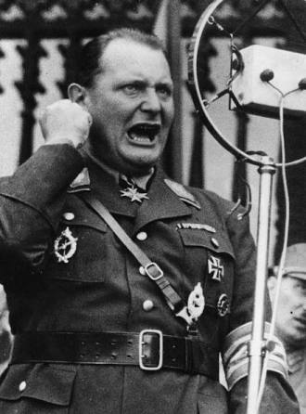
After Hitler, Goering was arguably the the most prominent man in the Nazi Regime. He was Commander-in-Chief of the Luftwaffe, Plenipotentiary for the Four Year Plan, and had tremendous influence with Hitler. He testified that Hitler kept him informed of all important military and political problems.
From the moment he joined the Party in 1922 and took command of the street-fighting organisation, the SA, Goering was the adviser, the active agent of Hitler and one of the prime leaders of the Nazi movement. As Hitler's political deputy he was largely instrumental in bringing the National Socialists to power in 1933, and was charged with consolidating this power and expanding German armed might. He developed the Gestapo, and created the first concentration camps, relinquishing them to Himmler in 1934, conducted the Roehm purge in that year, and engineered the sordid proceedings which resulted in the removal of von Blomberg and von Fritsch from the Army. In 1936 he became Plenipotentiary for the Four Year Plan, and in theory and in practice was the economic dictator of the Reich. Shortly after the Pact of Munich, he announced that he would embark on a five-fold expansion of the Luftwaffe, and speed rearmament with emphasis on offensive weapons.
Goering was one of the five important leaders present at the Hoszbach Conference of 5th November, 1937. In the Austrian Anschluss, he was indeed the central figure, the ringleader.
In the seizure of the Sudetenland, he played his role as Luftwaffe chief by planning an air offensive which proved unnecessary and his role as a politician by lulling the Czechs with false promises of friendship. The night before the invasion of Czechoslovakia and the absorption of Bohemia and Moravia, at a conference with Hitler and President Hacha he threatened to bomb Prague if Hacha did not submit. This threat he admitted in his testimony.
Goering attended the Reich Chancellery meeting of 23rd May, 1939, when Hitler told his military leaders " there is, therefore, no question of sparing Poland," and was present at the Obersalzburg briefing of 22nd August, 1939. And the evidence shows he was active in the diplomatic manoeuvres which followed. With Hitler's connivance, he used the Swedish businessman, Dahlerus, as a go-between to the British, as described by Dahlerus to this Tribunal, to try to prevent the British Government from keeping its guarantee to the Poles.
He commanded the Luftwaffe in the attack on Poland and throughout the aggressive wars which followed.
Even if he opposed Hitler's plans against Norway and the Soviet Union, as he alleged, it is clear that he did so only for strategic reasons; once Hitler had decided the issue, he followed him without hesitation.

As Luftwaffe Commander-in-Chief he demanded from Himmler more slave labourers for his underground aircraft factories.

As Plenipotentiary, Goering signed a directive concerning the treatment of Polish workers in Germany and implemented it by regulations of the SD, including " special treatment ". He issued directives to use Soviet and French prisoners of war in the armament industry; he spoke of seizing Poles and Dutch and making them prisoners of war if necessary, and using them for work.
As Plenipotentiary, Goering was the active authority in the spoliation of conquered territory. He made plans for the spoliation of soviet territory long before the war on the Soviet Union. Two months prior to the invasion of the Soviet Union, Hitler gave Goering the over-all direction for the economic administration in the territory. Goering set up an economic staff for this function. As Reichsmarshal of the Greater German Reich " the orders of the Reichmarshal cover all economic fields, including nutrition and agriculture." His so-called " Green " folder, printed by the Wehrmacht, set up an " Economic Executive Staff, East." This directive contemplated plundering and abandonment of all industry in the food deficit regions and from the food surplus regions, a diversion of food to German needs.

Goering persecuted the Jews, particularly after the November 1938 riots, and not only in Germany but also as other countries fell before the German army he extended the Reich's anti-Jewish laws to them; the Reichsgesetzblatt for 1939, 1940, and 1941 contains several anti-Jewish decrees signed by Goering.

- Karl Donit
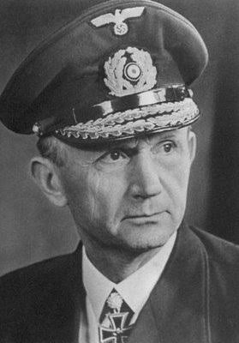
Karl Dönitz was born on 16 September 1891 near Berlin and went into the Imperial German Navy in 1911. He was promoted to midshipman a year later and to lieutenant in 1913. In World War I, he served on a light cruiser, SMS Goeben, in the Mediterranean before being appointed to a submarine fleet in October of 1916.xxv Submarines would later be central to Dönitz’s World War II strategy. While in command of UB-68 in 1918, Dönitz was taken prisoner as British forces sunk the submarine near Malta. His time as a prisoner in a war camp, though, was not unproductive; he formulated what he later called Rudeltaktik (“pack tactic” or “wolfpack” in English). He returned to Germany in 1920 and continued to rise through the ranks of the Germany navy until he received command of the first U-boat flotilla in September of 1935. He was the major proponent for the building of Nazi Germany’s U-boat fleet which was done in violation of the Versailles Treaty clauses still in effect at that time.
In World War 2, Donitz turned the U-boats into a serious threat to Britain's survival. Dönitz focused his fleet’s efforts against merchant traffic, believing that cutting off England’s import trade could bring about its capitulation. The U-boats, coordinated by radio using encoded messages, began to damage the British economy. As 1940, 1941, and 1942 passed, the fleet had more successful operations, including, notably, Operation Drumbeat. Under his guidance, by early 1941 the U-boat commanders were operating in his wolfpack formation and sinking 700,000 tons of Allied ships every month.
In January 1943, Dönitz replaced Grand Admiral Erich Raeder as Commander-in-Chief of the Navy.
On 30 April 1945, after the death of Adolf Hitler and in accordance with Hitler's last will and testament, Dönitz was named Hitler's successor as head of state, with the title of President of Germany and Supreme Commander of the Armed Forces.
After his succession, Dönitz opened negotiations for surrender. He wanted to save as many German civilians and retreating soldiers from the Soviets as possible, correctly believing that the Soviets would prove much less forgiving conquerors than the Western Allies. He hoped that a separate surrender to the British and Americans might allow the Reich to rescue something from the Soviets in the east. On 7 May 1945, he ordered Alfred Jodl, Chief of Operations Staff of the OKW, to sign the German instruments of surrender.

- Alfred Rosenberg
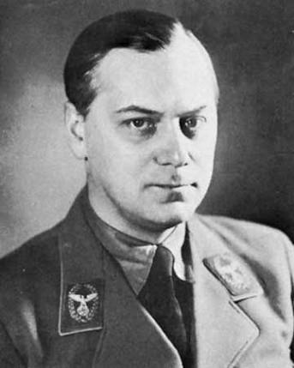
Rosenberg was the official National Socialist ideologist. Through the ideological tenets which he expounded he exerted an influence upon the unification of German thought, a unification which was an essential part of the conspirator's program for seizure of power and preparation for aggressive war.
Born the son of a cobbler in what was at the time a part of Russia, Rosenberg studied architecture in Moscow until the Revolution of 1917. After the Bolsheviks gained control of Russia Rosenberg moved to Germany where he settled with the large community of White Russians in Munich. In 1920 Rosenberg met Adolf Hitler in 1923 and according to Louis L. Snyder "Hitler was fascinated by the young man's seemingly vast fund of knowledge". Rosenberg joined the National Socialist German Workers Party (NSDAP) and in 1923 became editor of the party newspaper, Voelkischer Beobachter. As editor, Rosenberg drew on the ideas of the English racist Houston Stewart Chamberlain and on the Protocols of the Learned Elders of Zion, a 19th-century fabrication concerning a supposed Jewish plot for world domination. When Hitler was imprisoned after the Munich Beer Hall Putsch (November 1923), he made Rosenberg leader of the party, knowing him to be incompetent as an organizer and thus unlikely to establish a position of power.
Rosenberg encouraged the conquest of Poland and Russia, justifying it with the principles of racial superiority that went on to form the crux of Nazi social beliefs. He said Germans descended from a Nordic race that derived its character from its environment: a pure, cold, semi-Arctic continent, now disappeared. The Germans, as representatives of this race, were entitled to dominate Europe and eliminate racial impurity. Their enemies were “Russian Tartars” and “Semites.” The latter included Jews, the Latin peoples, and Christianity, particularly the Catholic Church.
Shortly after Hitler's appointment as Reich Chancellor in 1933, Rosenberg took charge of the Nazi Party's foreign policy office (Aussenpolitisches Amt der NSDAP). More party appointments followed, among them membership in the circle of the Party's top leadership as Reichsleiter(1933), and plenipotentiary for supervising the Party's ideological training (1934). A stepping-stone towards even greater political power came in 1938 when Hitler approved Rosenberg's idea for a new, fully Nazified university system (Hohe Schule) that would ground the Party's and the nation's future elite in racist ideology.
When the War started, Rosenberg claimed the existence of a “Jewish conspiracy” to confiscate books, artifacts and archived materials from Jewish organizations and homes throughout Europe. Founded in October 1940, his “Einsatzstab Reichsleiter Rosenberg” [Task Force of the Reichsleiter Rosenberg, or ERR] became the most successful Nazi organization engaged in art plunder. By the end of war, the ERR had shipped almost 1.5 million railcar-loads of artwork and artifacts from German-controlled Europe to the Reich.
On July 17, 1941, Hitler appointed him Reich Minister for the Occupied Eastern Territories [Reichsminister für die besetzten Ostgebiete], in charge of an area—yet to be occupied—stretching from the former Polish border in the west to the Ural mountains in the east.
The area under his authority was the first to see the “Final Solution of the Jewish Question” carried out through the systematic murder of Jewish men, women, and children. By the end of 1941, more than half a million Jews had been annihilated; Estonia, part of the “Reichskommissariat Ostland” was the first German-occupied region declared to be “free of Jews.” Since November 1941, trains with Jews deported from the Reich arrived in the “Ostland.” SS and police officers together with Rosenberg's officials made sure that the deportees were either killed immediately on arrival or exploited in forced labor projects few could survive.

4. Rudolf Hess

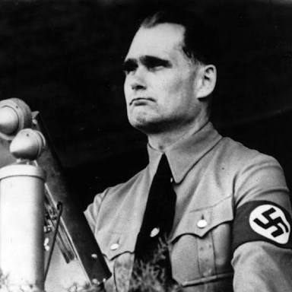
Rudolf Hess was born in Alexandria, Egypt, April 26, 1894, the son of a prosperous wholesaler and exporter. He did not live in Germany until he was fourteen. He volunteered for the German Army in 1914 at the outbreak of World War One, partly to escape the control of his domineering father who had refused to let him go to a university but instead persuaded him into an unwanted career in the family business.
In World War One, Hess was wounded twice, then later became an airplane pilot. After the war, Hess joined the Freikorps, a right-wing organization of ex-soldiers for hire, involved in violently putting down Communist uprisings in Germany.
At the University of Munich, Hess studied political science and came under the influence of the Thule Society, a secret anti-Semitic political organization devoted to Nordic supremacy. Hess was also influenced by Professor Karl Haushofer, a former general whose theories on expansionism and race formed the basis of the concept of Lebensraum (increased living space for Germans at the expense of other nations).
After hearing Adolf Hitler speak in a small Munich beer hall, Hess joined the Nazi Party, July 1, 1920, becoming the sixteenth member. After his first meeting with Hitler, Hess said he felt "as though overcome by a vision."
At early Nazi Party meetings and rallies, Hess was a formidable fighter who brawled with para-military Marxists and others who often violently attempted to disrupt Hitler's speeches.
In 1923, Hess took part in Hitler's failed Beer Hall Putsch in which Hitler and the Nazis attempted to seize control of Germany. Hess was arrested and imprisoned along with Hitler at Landsberg prison. While in prison, Hess took dictation for Hitler's book, Mein Kampf, and also made some editorial suggestions regarding Lebensraum, the historical role of the British Empire, and the organization of the Nazi Party.
After his release from prison in 1925, Hess served for several years as Hitler's personal secretary in spite of having no official rank in the Nazi Party. In 1932, Hitler appointed him Chairman of the Central Political Commission of the Nazi Party and SS General as a reward for his loyal service. On April 21, 1933, he was made Deputy Führer, a figurehead position with mostly ceremonial duties.
Hess was a shy, insecure man who displayed near religious devotion, fanatical loyalty and absolute blind obedience to Hitler. In 1934, Hess gave a revealing speech stating - "With pride we see that one man remains beyond all criticism, that is the Führer. This is because everyone feels and knows: he is always right, and he will always be right. The National Socialism of all of us is anchored in uncritical loyalty, in the surrender to the Führer that does not ask for the why in individual cases, in the silent execution of his orders. We believe that the Führer is obeying a higher call to fashion German history. There can be no criticism of this belief."
One of his most visible tasks was to announce the Führer at mass meetings with bellowing, wide eyed fanaticism, as seen in the Nazi documentary, Triumph Of The Will.
Although often rewarded by Hitler for his dogged loyalty, Hess was never given any major influence in matters of state due to his lack of understanding of the mechanics of power and his inability to take any action on his own initiative. He was totally and deliberately subservient to his Führer.
He was granted titles such as Reich Minister without Portfolio, member of the Secret Cabinet Council, and member of the Ministerial Council for Reich Defense. In 1939 Hess was even designated to be Hitler's successor after Göring.
But over time, his limited power was further undermined by the political intrigue of the top Nazis around Hitler who were constantly scheming for personal power. Hess had only one desire, to serve the Führer, and thus lacked the will to engage in self serving struggles for power and lost out primarily to his subordinate and eventual successor, Martin Bormann. As a result, Hitler gradually distanced himself from Hess.
Hoping to regain importance and redeem himself in the eyes of his Führer, Hess put on a Luftwaffe uniform and flew a German fighter plane alone toward Scotland on a 'peace' mission, May 10, 1941, just before the Nazi invasion of the Soviet Union. Hess intended to see the Duke of Hamilton, who he had met briefly during the Berlin Olympics in 1936.
With extra fuel tanks installed on the Messerschmitt ME-110, Hess, an expert flier, made the five hour, 900 mile flight across the North Sea and managed to navigate within 30 miles of the Duke's residence near Glasgow, Scotland. At 6,000 feet Hess bailed out and parachuted safely to the ground then encountered a Scottish farmer and told him in English, "I have an important message for the Duke of Hamilton."
Hess wanted to convince the British Government that Hitler only wanted Lebensraum for the German people and had no wish to destroy a fellow 'Nordic' nation. He also knew of Hitler's plans to attack the Soviet Union and wanted to prevent Germany from getting involved in a two-front war, fighting the Soviets to the east of Germany, and Britain and its allies in the west.
During interrogation in a British Army barracks, he proposed that if the British would allow Nazi Germany to dominate Europe, then the British Empire would not be further molested by Hitler. He insisted that German victory was inevitable and even threatened that the British people would be starved to death by a Nazi blockade around the British Isles unless they accepted his generous peace offer.
But Hess also displayed signs of mental instability to his British captors and they concluded he was half mad and represented only himself. Churchill, realizing this, and somewhat infuriated by his statements, ordered Hess to be imprisoned for the duration and treated like any high ranking POW.
Hess was declared insane by a bewildered Hitler, and effectively disowned by the Nazis. His flight ultimately caused Hitler and the Nazis huge embarrassment as they struggled to explain his actions.
During his years of British imprisonment, Hess displayed increasingly unstable behavior and developed a paranoid obsession that his food was being poisoned. In 1945, Hess was returned to Germany to stand trial before the International Military Tribunal at Nuremberg.

5. Ernst Kaltenbrunner

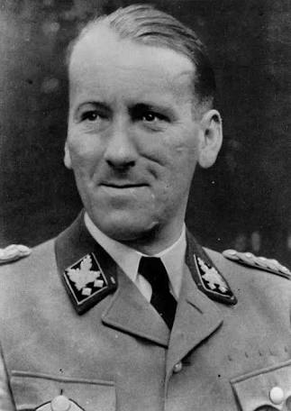

Kaltenbrunner joined the Austrian Nazi Party on 31 August 1931. He was admitted to the Bar in 1933. The intelligent, tall (6'7") and imposing Kaltenbrunner provided legal advice to, and gained prominence within the Nazi Party quickly, so that by mid 1935 he was appointed to head the Austrian SS. He assisted in the advance work for the Anschluss, and in recognition of his services on the day the Anschluss was secured Hitler, also Austrian born, promoted Kaltenbrunner to SS-Brigadefürhrer (equivalent to Brigadier General) and assigned him to head the SS Oberabschnitt Donau (SS Upper Danube section). He became a member of the Austrian Government taking over the position of State Secretary for Security in Austria, which was under the Ministry of the Interior. Among his first tasks was to assist the development of the new Mauthausen concentration camp. Construction commenced in August 1938 with prisoners brought in from the Dachau camp. Kaltenbrunner was promoted yet again on 11 September 1938 to SS-Gruppenfürhrer (Major General).
SS-Brigadefurhrer Ernst Kaltenbrunner (56,960 bytes) After Anschluss the prior Austrian national government was dissolved, and Austria's provinces were reorganized into Alps and Danube Districts. Kaltenbrunner was appointed the Higher SS and Police Leader of the Governors of Vienna, Lower Danube, and Upper Danube, and of Wehrkreis XVII (Corps Area). In April 1941 was promoted to Major General of the Police; he supervised and had knowledge of the activities of the Geheime Staatspolizei (Gestapo) and of the Sicherheitsdienst (Security Service) in Austria. Kaltenbrunner was also helpful in aiding those efforts of industry including Steyr-Daimler-Puch to obtain prison labor. Fellow Austrian Georg Meindl, Generaldirektor of Steyr-Daimler-Puch, nurtured his access to those in the Nazi hierarchy and made it a point to ingratiate himself with Kaltenbrunner and Himmler.
Kaltenbrunner promoted to SS-Obergruppenführer, a rank equivalent to Lieutenant General and just below that of Himmler's special rank of Reichsführer SS.
Left: SS-Brigadefürhrer Ernst Kaltenbrunner. Photo taken between 12 March and 10 September 1938 (44,917 bytes).
The Reichssicherheitshauptamt (Reich Main Security Office), or RSHA, was an organization within the SS created by Reichsführer-SS Himmler on 27 September 1939. The organization incorporated the SS intelligence services: Sicherheitsdienst (SD) or Security Service, the Sicherheitspolizei (SiPo) or Security Police which were nominally under the Interior Ministry. SiPo was composed of the Geheime Staatspolizei (Gestapo, Secret State Police) and the Kriminalpolizei (Kripo, Criminal Police). The mission of the RSHA was to identify and eliminate all "enemies of the Reich" inside and outside the borders of Nazi Germany. The acronym for its director was 'CSSD': Chef der Sicherheitspolizei und des SD (Chief of the Security Police and of the Sicherheitsdienst). The CSSD reported directly to Heinrich Himmler in his dual capacities as Chef der Deutschen Polizei (Chief of German Police) and Reichsführer-SS. The first CSSD was SS-Obergruppenführer and General of Police Reinhard Heydrich (b. 7 March 1904). Heydrich was so ruthless and competent that he was widely regarded as the most feared man in Nazi Germany.
In April 1941 Kaltenbrunner was appointed Lieutenant-General of Police. In May 1942 Kaltenbrunner was appointed head of the SD (Sicherheitsdienst). In this position he not only controlled the Gestapo but also the concentration camp system and was responsible for implementation of the Final Solution, the extermination of the Jewish race in German-occupied Europe. He had much to do with developing the Mauthausen concentration camp and visited it frequently, especially while his duties kept him in the region. On at least one occasion Kaltenbrunner observed the murder of prisoners in the camp poison gas chamber.
Heydrich was appointed to manage the German-occupied Czechoslovakia. He was seen as such a threat that the Allies trained a Czechoslovak commando team to enter Czechoslovakia, and to assassinate him. Their attack on 27 May 1942 wounded Heydrich, and he died in hospital of septicemia on 4 June 1942. Following Heydrich's assassination Himmler personally took over as acting chief of the RSHA. After considering With Kaltenbrunner's knowledge and background Himmler recommended him, and on 30 January 1943 Hitler delegated the office to Kaltenbrunner; he would head the RSHA for the remainder of World War II. Kaltenbrunner was now administering the very agencies which sent millions of victims to their deaths with his stroke of a pen implementing The Final Solution planned under Heydrichs' tenure but implemented under Kaltenbrunner.
On 21 June 1943 Kaltenbrunner was promoted to SS-Obergruppenführer und General der Polizei:
Autograph of SS-Obergruppenfuhrer und General der Polizei Ernst Kaltenbrunner (22,309 bytes)
After the failed assassination attack on 20 July 1944 that wounded Adolph Hitler, Kaltenbrunner was assigned to manage the investigations and prosecution of those implicated in the plot. He was occasionally seen attending some of the trials, and this no doubt motivated the SS Judges and prosecutors to put on an even better 'show'. His new status gained for him direct access to Hitler, and this increased his prestige and influence within Nazi Germany. Kaltenbrunner received honors from Hitler, and engendered Hitler's personal trust.
As reality set in some months after the June 1944 D-Day landings and the progress of the Allies through France, SS General Officers were granted equivalent Waffen-SS ranks so that if they were captured by the Allies then they would be granted the privileges expected to be provided to a military officer instead of administrative or police officials. On 1 December 1944 Kaltenbrunner's title became SS-Obergruppenführer und General der Polizei und Waffen-SS.
In the morning of 12 May 1945 Kaltenbrunner was arrested by a US Counter-intelligence Corps (CIC) team including intelligence officer Robert Matteson, with squad support from the 80th Infantry Division, Third U.S. Army. He was found hiding in a remote cabin called Wildenseehütte, atop the Totes Gebirge mountains in Austria.

6. Walther Funk

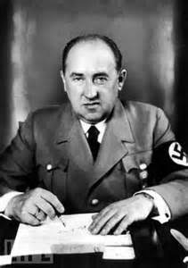

Walther Funk was a seniorNazi Party official who served in Adolf Hitler’s cabinet as Minister of Economics. Funk also served as President of the Reichsbank.
Walther Funk was born in Trakehnen, East Prussia, on August 18th 1880. It was quickly apparent to his family that he was a very able boy in a great number of subjects. From school Funk went to the University of Berlin where he studied economics, philosophy and law. Funk was drafted into the German Army in 1916 but received a medical discharge as a result of ill-health.
Funk then joined the staff of the ‘Berliner Boersenzeitung’, a conservative newspaper. In 1920, he became chief editor of its business section. From 1922 to 1932, Funk worked as the newspaper’s editor.
Funk, along with many others in Weimar Germany, was an ardent nationalist and he had no faith in the politicians who governed Germany then. Funk believed that Germany needed strong leaders who would push Germany back to greatness. In 1931 he met Adolf Hitler and he was quickly taken in by him. Hitler was also impressed with Funk and made him his personal economics advisor. Funk advised Hitler that the best way forward for Germany in terms of getting out of economic depression was to embrace public work schemes based around a huge road building programme. He also saw a huge expansion in the car industry as a way forward as well as a way for Germany to show the world that Germany was now back as a world power. New autobahns and a mass of new cars using them was, Funk believed, a very overt message to the world. Funk also believed that Germany needed to be more self-sufficient in terms of food production and less reliant on foreign food imports. Therefore he advised that there should be a massive expansion in agriculture.
In March 1933, Funk was appointed Press Chief of the Reich government and Under-Secretary of the Reich Ministry for Public Enlightenment and Propaganda. His immediate superior was Joseph Goebbels. Funk also sat on the board of directors of the Reich Broadcasting Company. In 1938, he succeeded Hjalmar Schacht as Minister of Economics and in 1940 he took over Schacht’s other post – President of the Reichsbank. With these two positions, Funk had control over Nazi Germany’s economic and financial policies. In 1942 Funk agreed with Heinrich Himmler that the Reichsbank would receive valuables taken from those who had been sent to the death camps. It is said that Himmler made it clear to Funk that no questions were to be asked about where the valuables came from – the Reichsbank was simply there to look after them.
Funk was a diligent and loyal party man. He fervently believed that Hitler was the only man who could save Germany from communism. He used the skills he had acquired working in newspapers to all-but eulogise what Hitler was doing for Nazi Germany. Some, such as Schacht, held him in contempt but this may have been because Funk replaced him in both of his high ranking positions. Others saw Funk as a loyal party functionary who gave what was needed to Hitler and therefore, de facto, to Nazi Germany.
Funk was arrested at the end of the war and on October 20th 1945.

COMMITTEE PROCEDURE

Day 1 (Pre-Trial)

There will be a 3 hour session prior to the two MUN days, before which all delegates must have finished their research. We will begin with an introduction to the committee and explain the procedure followed by the committee as well as what is expected of all the delegates.
Following this, we will have the Submission of Evidence for each of the trials. This is when the prosecution and defense will present their evidence and try to get as much of their evidence submitted. To conduct this the delegates must be well researched and, if possible, have hard copies of the evidence that they wish to submit. In cases of dispute, the Executive Board will make the final verdict on what evidence is allowed and what is not.

Day 2 & 3 (Trial)

Three trials will be conducted on each day. A trial will include opening statements from both prosecution and defense which will be for 15 minutes each and then a 5 minute rebuttal from each side. The delegates who are not participating in the trial will act as judges and will give a Guilty or Not Guilty verdict as per their discretion and a justification for their verdict. The verdict will be decided by a simple majority and the Executive Board will also take part in the voting. Each trial should take about one hour to complete.
DELEGATE TO DO LIST

As all of you will be lawyers conducting the trial in 1945, events taking place afterwards (including the verdicts of the actual historical trials) will not be submissible. Once the actual facts regarding the war and actions of the defendants are established, we encourage both sides to consider principles like:

- The Territoriality Principle
- Principle of Universality
- Implications for International Justice
- International Law established before 1945, as well as legal precedence for war crimes (eg. the Leipzig Trials)
- The legal authority of this committee to enact certain sentences
- Whether superiors are liable for actions of their inferiors, and whether someone is liable for orders or laws followed

Prosecuting Attorneys

- Be well versed with the biography of the defendant, especially his actions during the war.
- Know all of the accusations against the defendant
- Find documentation to use as evidence for the accusations against your defendant. Documentation can be of any form - reports, articles, photos, footage - but its admissibility will be ruled upon by the judges.
- Build a case to convince the judges of the court to prosecute the defendant based on principles of international and humanitarian justice.
- Be familiar with the general conduct and legal terms used by a prosecuting attorney.
.

Defense Attorneys

The mandate of the defense is to clear the defendants of their charges and making a case for restraint on behalf of the international community.

- Be well versed with the biography of the defendant, especially his actions during the war.
- Know all of the accusations against the defendant
- Be prepared with rebuttals for all the accusations against the defendant. If you cannot deny the actions undertaken by the defendant, focus on international precedence and whether the court can legally prosecute the defendant on those charges.
- Develop and build strong questions for the prosecution that can validate the innocence of their defendant.
- Find documentation to use as evidence for defense. Documentation can be of any form - reports, articles, photos, footage - but its admissibility will be ruled upon by the judges.
- Be familiar with the general conduct and legal terms used by a defense attorney.

REFERENCES

http://www.jewishvirtuallibrary.org/nuremberg-trial-judgements-hermann-goering
https://issuu.com/ymun/docs/rb_nurembberg_final
http://www.jewishvirtuallibrary.org/nuremberg-trial-defendants-karl-doenitz
https://www.britannica.com/biography/Alfred-Rosenberg
http://www.bbc.co.uk/history/historic_figures/donitz_karl_admiral.shtml
http://hcmun.com/bg/hcmun-UNHRC.pdf
http://www.historyplace.com/worldwar2/biographies/apr-hess-cal.htm
http://www.company7.com/bosendorfer/mauthausen/ernst_kaltenbrunner_testimony.html
http://www.historylearningsite.co.uk/nazi-germany/nazi-leaders/walther-funk/
http://www.history.com/this-day-in-history/nuremberg-war-crimes-trials-begin
https://www.icrc.org/eng/assets/files/other/what_is_ihl.pdf
http://www.pbs.org/wgbh//amex/nuremberg/peopleevents/p_prosecutors.html

