**Background Guide**

North Atlantic Treaty Organization (NATO)



**Table Of Contents**

1. Letter from the Executive Board
2. Section A: Introduction to the NATO
   1. History and Formation
   2. Powers and Functions
   3. Timeline of Key Events
   4. The North Atlantic Treaty
      1. Article 4
      2. Article 5
3. Section B: The Crisis at Hand
   1. Situation in Paris
   2. Intelligence Report on the Soviet Revolutionary Party
4. Section C: Foreign and Military Policy of the NATO
   1. Military Policy
   2. Role of the USA
      1. DEFCON
      2. NORAD
   3. Tension in the Crimean Peninsula
5. Section D: What’s Special About Crisis Committees?
   1. An (Biased) Introduction
   2. Modes of Documentation
      1. Committee Directives
      2. Individual Directives
      3. Communiques (Crisis Notes)
      4. Press Statements
   3. Tips and Suggestions
6. References, Points to Note and Further Reading
7. **Letter from the Executive Board**

Greetings Delegates,

It is our absolute honour and privilege to serve as your Executive Board for this iteration of ShriMUN. Each of us has a fruitful and lasting relationship with Model UN: it has widened both the depth and breadth of our knowledge, honed and sharpened our critical analysis skills, and taught us the value of perspective.

We hope that you too adopt this view of MUN being a unique social and intellectual experience. Beyond elaborate dresses and perfectly tied ties, you must *collectively* rise to the occasion of not making the mistake of judging people and problems at face value. Every issue that plagues the world today must be examined through a kaleidoscope of different lenses to truly understand the dynamics of global actors.

We have worked countless hours to ensure quality updates and crises, but this is your platform to shine. The future and integrity of Europe and this transatlantic alliance lies in your hands. Through nuanced debate and intense negotiations, it is our hope that this committee will alter your perception of the complex web of relationships that ties each nation to another.

With the only constraints being realism and flawless justifications, we give you the license to perform what it takes to lead your country to unfettered heights.

Regards,

Preetika Pahwa Vedant Chandra Raman Thadani

**2. Section A: Introduction to the NATO**

**2.1. History and Formation**

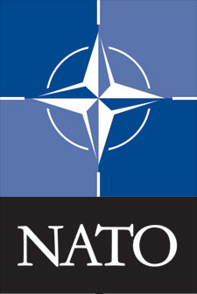

The conflict between western nations (including the United States, Great Britain, France and other countries) and the communist eastern bloc (led by the Union of Soviet Socialists Republics or USSR) began almost as soon as the guns fell silent at the end of World War II (1939-45). The U.S. and its western allies sought ways to prevent further expansion of communist influence on the European continent.[1]

With the primary objective of ensuring prosperity and maintaining peace in the ravaged nations, US President Franklin Roosevelt and UK Prime Minister Winston Churchill met to sign the Atlantic Charter in April 1949. The Atlantic Charter was a precursor to the North Atlantic Treaty. It was based upon democratic ideals, which emphasized on national self-determination (rights of the citizens to choose their own government and nations). It also called upon nations to be a part of an international collaboration that would promote free trade, improve labor conditions and ensure overall economic development as well as social security. As a result, several western European democracies came together with the objective of promoting greater military cooperation, collective defence, free trade and protection of democratic ideals.

In 1948, there were widespread fears of Soviet expansion and its aggression as well as the German resurgence. The communist coup d’etat in Czechoslovakia and the Berlin Blockade the same year, further triggered reminders to the whole world of Soviet aggression. These events caused the United Kingdom, France, Belgium, Luxembourg and the Netherlands to come together in 1948 and sign the Treaty of Brussels. This treaty created a basis of a military alliance.

In due course of time, the **Atlantic Charter** and the **Treaty of Brussels** came together in 1949, when 10 Western European countries and two from North America (Belgium, Denmark, France, the Netherlands, Iceland, Canada, Luxembourg, Norway, Portugal, USA, United Kingdom and Italy)convened in Washington DC to sign the **North Atlantic Treaty** in April, 1949.

The creation of the Alliance was meant to serve three purposes:

1. balancing the influence of the western and eastern powers,
2. preventing and hindering the revival of nationalist militarism in Europe through a strong North American presence on the continent,
3. and encouraging an overall European political integration.

Throughout the Cold War, NATO expanded strategically. It continued to pursue the principle of containment and added members from various parts of Europe. Together with security guarantees and material aid from the USA, Western Europe has achieved stability and economic development. NATO’s primary objective to protect and uphold the sovereignty of its member nations still remains.

**2.2. Powers and Functions**

The **North Atlantic Treaty Organisation**, also known as the **North Atlantic Alliance**, was founded as a result of the **North Atlantic Treaty**, which was signed on 4th April 1949. It is arguably the largest and the most powerful military alliance in the world. When it was incepted, it initially consisted of 12 founding members. Over the decades, NATO has expanded in terms of its size and now consists of **28 independent member countries** across both sides of the Atlantic, the North American and the European continent. These countries meet at its headquarters in Brussels to promote international cooperation in tightening defence and security ties.

NATO has two distinct categories of functions, each crucial to maintaining transatlantic ties with regards to peace and security.

* **POLITICAL**: NATO promotes democratic ideals and encourages consultation and cooperation on defence and security issues to build trust and, in the long run, prevent conflict.
* **MILITARY:** NATO is committed to the peaceful resolution of disputes. If diplomatic efforts fail, it has the military capacity needed to undertake crisis-management operations. These are carried out under Article 5 of the Washington Treaty - NATO’s founding treaty - or under a United Nations mandate, alone or in cooperation with other countries and international organizations.[2]

Therefore, NATO’s essential purpose is to safeguard the freedom and security of its members through political and military means.

Delegates must bear in mind that NATO is a *consensus* organisation, rather than one based on *compromise*. Compromising on issues of national security only stores up resentment and bad blood for the future. Therefore, NATO seeks to evolve a system which limits the actions of the Alliance to only those issues on which “consensus” can be achieved. By aligning national interests only in these areas, there is no essential loss of sovereignty and no threat to Allies’ national interests. Even though running on the basis of absolute consensus is laborious and often acts as a hindrance, it is what gives NATO its distinctly unique nature in that each party feels a sense of solidarity and belongingness to the alliance.

The NATO Secretary General serves the member nations, administers the HQ, and acts as the chief figurehead of and spokesman for the Alliance.[3]

NATO’s modern defence posture is based on an effective combination of cutting-edge weapons systems and platforms, and forces trained to work together seamlessly. As important as it is that Allies invest in defence, it is also critical to invest in the right capabilities. NATO plays an important role in assessing what capabilities the Alliance needs, setting targets for national or collective development of capabilities, and facilitating national, multinational and collective capability development and innovation.[4]

NATO has an open-door policy towards the membership of European nations, i.e. *NATO membership is open to “any other European state in a position to further the principles of this Treaty and to contribute to the security of the North Atlantic area.”*

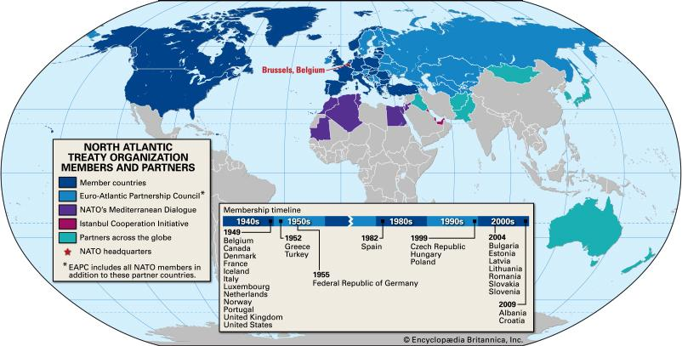

**2.3. Timeline of Key Events**

This is a summarised timeline of the key events. Delegates are encouraged to be informed about the past and ongoing actions of the NATO and well-researched about its functioning.

**4 April 1949 -** USA, Canada, and 10 Western European countries sign the North Atlantic Treaty. The treaty provides for mutual assistance, including military, in case of an attack on a party or parties to the Treaty.

**2 April 1951 -** in Rocquencourt on the outskirts of Paris, allied command operations are commenced at SHAPE - Supreme Headquarters of Allied Powers in Europe.

**18 February 1952** - Greece and Turkey become members of NATO.

**6 May 1955 –** the Federal Republic of Germany becomes a member of NATO. This triggered the creation of the Warsaw Pact coalition. It was created by the USSR, along with Albania, Bulgaria, Czechoslovakia, Hungary, Poland, Romania and the German Democratic Republic.

**14 May 1955** – founding of the Warsaw Pact.

**1956 -** the Suez Crisis leads NATO to strengthen its political role. Intervention of the Warsaw Pact countries in Hungary.

**1957 -** USSR pushes ahead of the West in the race for space exploration by launching the first artificial satellite into orbit.

**23 May 1957 -** NATO adopts a defensive strategy of massive retaliation; nuclear capacity of the United States becomes the basis of the security of NATO member states.

**1961 -** Erection of the Berlin Wall.

**1962 -** Cuban Missile Crisis.

**10 March 1966 -** President Charles de Gaulle decides on France’s exit from NATO's military structures; France remains a member of the civilian structures.

**1967 -** The headquarters of NATO is transferred from France to Casteau, near Mons in Belgium. Publication of the "Harmel Report" declaring that an element of balance was to improve relations with the Eastern bloc, and NATO was assigned two equally important missions: defense of the member states and relaxation of relations (detente) with communist countries.

**16 January 1968 -** NATO adopts a strategy of flexible response.

**1 August 1975 -** signing of the Helsinki Accords, in which Western countries and the Eastern bloc reiterated their commitment to noninterference in internal affairs, peaceful settlement of international disputes and respect for human rights.

**9-10 December 1976 -** NATO rejects Warsaw Pact proposal that both parties renounce nuclear first strike.

**1978 - 1986 -** deployment of Soviet intermediate-range ballistic missiles capable of conducting a limited nuclear war in Europe.

**1984 -** deployment by NATO of intermediate-range ballistic missile in response to arms buildup by USSR.

**8 December 1987 –** USA and Soviet Union sign INF Treaty.

**1989 -** beginning of the fall of communism in the countries of Central and Eastern Europe.

**19 November 1990 -** Joint Declaration on Non-Aggression by countries of the Warsaw Pact and NATO.

**1991 -** dissolution of the Warsaw Pact and the Soviet Union.

**7-8 November 1991 -** NATO summit in Rome and adoption of a new NATO Strategic Concept.

**1994 -** beginning of the Partnership for Peace program.

**16 December 1995 -** beginning of the peacekeeping operations in Bosnia.

**12 March 1999 -** Poland, the Czech Republic and Hungary become members of NATO.

**24 March 1999 -** beginning of air strikes in Yugoslavia to protect the civilian population of Kosovo.

**12 September 2001 -** NATO invokes Article 5 of the North Atlantic Treaty for the first time as a result of the terrorist attacks in the United States on 11 September 2001.

**2002 -** Creation of NATO-Russia Council strengthens relations. NATO states that it will operate when and where necessary to fight terrorism.

**11 August 2003 -** NATO stabilization mission begins in Afghanistan, which is the first deployment of NATO forces outside the borders of the North Atlantic Treaty for the Kabul-based peacekeeping mission. It resulted in one of the deadliest ground combat missions for NATO in terms of overall casualties.

**2 April 2004 -** Bulgaria, Estonia, Lithuania, Latvia, Romania Slovakia and Slovenia became members of NATO.

**25 June 2007 -** Jaap de Hoop Scheffer, NATO Secretary General, announces a plan for a missile defence system on the eastern flank of NATO.

**2-4 April 2008 -** NATO invites Albania and Croatia to join during summit in Bucharest; the Alliance does not offer an Action Plan for Membership of Georgia or Ukraine.

**7-8 August 2008 -** beginning of Russian-Georgian war. NATO declared that formal relations with Moscow would be difficult unless Russia withdrew its military troops out of Georgia. Subsequently, Russia ceased all military cooperation with NATO.

**19-20 November 2010 -** NATO summit in Lisbon and adoption of a new Strategic Concept.

**2014 -** Annexation of the Crimea and the beginning of the Russo-Ukrainian war.

**April 2014 -** NATO unanimously decides to end co-operation with Russia in response to aggression in the Ukrainian situation and annexation of the Crimean Peninsula

**4-5 September 2014 -** NATO summit in Newport and adoption of the "Plan for Preparedness" enhancing the Alliance's capabilities in case of a threat to the territory of the Member States.

**September 2014 -** US President Barack Obama visits the Baltic States, reassuring Leaders that they will be protected by the alliance in case of any threats, including Russian aggression.

**September 2015 -** Russia begins bombing in Syria, supposedly to combat ISIS. However, the international community accuses Russia of bombing anti-Assad rebels at the request of Assad.

**June 2016** - Lithuania holds Iron Wolf, one of the NATO’s largest training exercises.

**2017 -** a case is filed at the UN’s highest court by Ukraine against Russia, accusing it of illegally annexing Crimea and illicitly funding separatist rebel groups in eastern Ukraine. A total of 8,000 NATO soldiers deployed to the Finnmark region of northern Norway, 160-300 km from Russian border, for a series of joint military exercises.

*(NATO stresses that military measures do not guarantee safety, and that meeting today's challenges requires the cooperation of the international community, which should work to prevent conflicts; when they do occur, the international community should strive after their completion to rebuild economic infrastructure and secure stabilization. Experiences from the Middle East and the Balkans show that averting crises requires political, military and civilian measures be taken simultaneously, along with the cooperation of other international actors such as the UN, OSCE, and the EU.[5])*

**2.4. The North Atlantic Treaty**

The North Atlantic Treaty is NATO’s founding treaty. It is anchored in the principles of collective security and containment. The legal basis for the creation of NATO is Article 51 of the UN Charter, which affirms the right of states to both individual and collective self-defence. The given link in referencing contains the North Atlantic Treaty, more popularly known as the Washington Treaty, signed by the 12 founding members of the Alliance, as well as the Accession Protocols for the 16 countries which have joined the Organization since 1949.[6]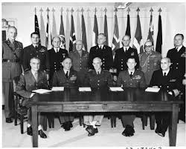

The North Atlantic Treaty is anchored in the principles of collective security and containment. Article V of the treaty affirms that “an armed attack against one or more (Member State) shall be considered an attack against them all” and as such member states of NATO can choose to react individually or collectively under NATO. The treaty further commits Member States to place the alliance in the highest priority and not engage in other international commitments which might contradict the spirit of the alliance.

The principle of collective self defence is at the very heart of this treaty. It remains a unique and enduring principle that binds its members together, committing them to protect each other and setting a spirit of solidarity within the Alliance. Article 5 provides that if a NATO ally is the victim of an armed attack, each and every other member of the alliance will consider this act of violence as an armed attack against all members and will take all actions necessary to assist the attacked.

**2.4.1. Article 4**

Consultation is a key part of NATO’s decision-making process. All decisions on all subjects of interest to the Alliance are made by discussion and consultation amongst member countries. They exchange views and information and hence, achieve a consensus. This is a major part of the political approach followed by NATO and allows countries to voice their opinions. It is a continuous process and takes place both on a formal and an informal basis.

It also gives NATO an active role in preventive diplomacy by providing the means to help avoid military conflict. Article 4 of the North Atlantic Treaty gives this platform. It states: *“The Parties will consult together whenever, in the opinion of any of them, the territorial integrity, political independence or security of any of the Parties is threatened.”*

This means members can bring any issue of concern, especially related to the security of a member country, to the table for discussion within the North Atlantic Council. Any member can formally invoke Article 4 of the treaty and other members are encouraged to react to the situation brought to their attention by a member country.

Since the Alliance’s creation in 1949, Article 4 has been invoked several times. For example, on 26 July 2015, Turkey requested that the North Atlantic Council (NAC) convene under Article 4 in view of the seriousness of the situation following heinous terrorist attacks, and to inform allies of the measures it is taking. Poland also invoked Article 4 on 3 March 2014 following increasing tensions in the neighbouring Ukraine.[7]

**2.4.2. Article 5**

Article 5 of the North Atlantic Treaty states: *“The Parties agree that an armed attack against one or more of them in Europe or North America shall be considered an armed attack against them all and consequently they agree that, if such an armed attack occurs, each of them, in exercise of the right of individual or collective self-defence recognized by Article 51 of the Charter of the United Nations will assist the Party or Parties so attacked by taking forthwith, individually and in concert with the other Parties, such as it deems necessary, including the use of armed force, to restore and maintain the security of the North Atlantic area.*

*Any such armed attack and all measures taken as a result thereof shall be reported to the Security Council. Such measures shall be terminated when the Security Council has taken the measures necessary to restore and maintain international peace and security.”*

What this essentially implies is that if one NATO member-state is attacked, it shall be **considered as an attack on all members of NATO; thus, all NATO states shall take all means necessary to eliminate the threat.**

This article sets a spirit of solidarity in the Alliance through the unique principle of collective self defence by committing all member states to protect each other. NATO has taken collective self defence measures several times. It invoked Article 5 for the first time in its history after the 9/11 terrorist attacks against the United States. NATO has now also agreed that a cyber attack can, under certain conditions, be considered as an act of aggression that would require an Article 5 response. Other examples where NATO has taken collective self defence measures are NATO in response to the situation in Syria and in the wake of the Russia-Ukraine crisis. NATO also has standing forces on active duty. They contribute to the Alliance’s collective defence efforts on a permanent basis.

A clarification of Article 5 is that it is not only based upon the principle of providing collective self-defence, but also to **provide assistance**. This means that the assistance provided by the Allies is not necessarily solely militaristic. Hence, it is an individual obligation and after consultation with other members, allies may provide any form of assistance they deem necessary to respond to a situation. Overall, it should be kept in mind that every action has an **ultimate aim to restore and maintain the security of the North-Atlantic region.**

**3. Section B: The Crisis at Hand**

From: Jens Stoltenberg, Secretary-General of NATO

June 1st, 2019. 1100 hrs.

Greetings member-states,

It is on a solemn note that I painfully inform you of the cloud of evil and malice that now surrounds our western civilization. Our peaceful and harmonious existence is threatened by extremist revolutionaries.

Since our inception in 1949, we have worked untiringly to protect the rights of our members. We must rise once again and bear the mantle of responsibility of restoring rightful order in this world. Let us not forget that this organisation believes in all for one, and one for all.

Please find hereunder a report submitted by the Republic of France which invoked Article 4 and caused this Emergency Session.

May God save us all.

Jens Stoltenberg

**3.1. Situation in Paris**

*Date: 1st June, 2019*

*Paris, 0430 hrs.*

**There has been complete takeover of the US and UK embassies in Paris, where American Secretary of State Rex Tillerson and British Foreign Secretary Boris Johnson are on visit.**

1. *A loud explosion is heard at the West Wing of the US embassy in Paris, engulfing the building in a swarm of chaos. Alarms are raised, but within 3 minutes, paramilitary forces have overtaken the building and are moving into Secretary Tillerson’s temporary residence.*
2. *Meanwhile, no visible panic is seen near the British embassy. However, as security protocol, French special forces (COS) at 0502 hrs attempts to secure its perimeter. None of their men returned.*
3. *At 0518 hrs, Flight KY308 which declared code red at 0447 hrs from Frankfurt to Charles de Gaulle airport crashes cataclysmically into the Air Traffic Control (ATC) tower, killing 210 German civilians while also resulting in a complete loss of operational capabilities.*
4. *While French supreme command prepares to storm the US embassy with an astronomical build-up of 230 men armed with RPGs, an urgent call from the White House Situation Room sounds, where the President, VP, Speaker, Secretary of Defense and Joint Chiefs of Staff have assembled, demanding that the invasion be called off citing concerns for Tillerson’s life.*
5. *‘Les Parisiennes’, who have now awoken at 0610 hrs watch in horror as two helicopters and combat aircraft land on the main runway of Charles de Gaulle despite military warnings to not do so. Seconds later, swathes of armed men in black masks storm the airport with incendiaries, causing superfluous damage.*
6. *Utter panic seizes the city as shops, buildings and monuments explode in timber and dust, with massive fires consuming parts of this historic city.*
7. *At 0730 hrs, the Republic of France declares a state of emergency, invokes Article 4 of the North Atlantic Treaty and calls for ‘urgent military and humanitarian aid’ from member-states of NATO.*
8. *The CIA intercepts and breaches lines of communication with the US embassy, where dozens of the extremist Soviet Revolutionary Party’s most able military commanders have held over 60 American diplomats hostage, including Secretary Tillerson. On asking the terrorists as to what they desire, the American ambassador to France is shot at point blank.*
9. *At 0905 hrs, a detailed military white paper is faxed to the office of the White House, demanding the unconditional, immediate release of General Igor Petrov, a war criminal, mastermind and founder of the Soviet Revolutionary Party, who has been sentenced to death for crimes against humanity.*

**3.2. Intelligence Report on the Soviet Revolutionary Party**

***The SRP* (Партия советского революционера) *is purely fictional and has been created for this committee.***

Founded in 2009, the SRP is an **intensely far-left and revolutionary organisation** which aimed to **overthrow government in former Soviet states such as Kazakhstan and South Slav regions in order to establish a despotic and authoritarian regime.** The long-term aspiration of the organisation, which has been labelled as ‘extremist’ and ‘anti-democratic’, is to **unify all East European states** forcefully to restore the perceived former glory of the USSR. However, given the vast ideological differences between some of these states (such as Estonia, Latvia, Lithuania etc. which are part of NATO, and Russia, which has historically followed policies to combat the growing US presence in Europe), such an attempt of unification is mocked at.

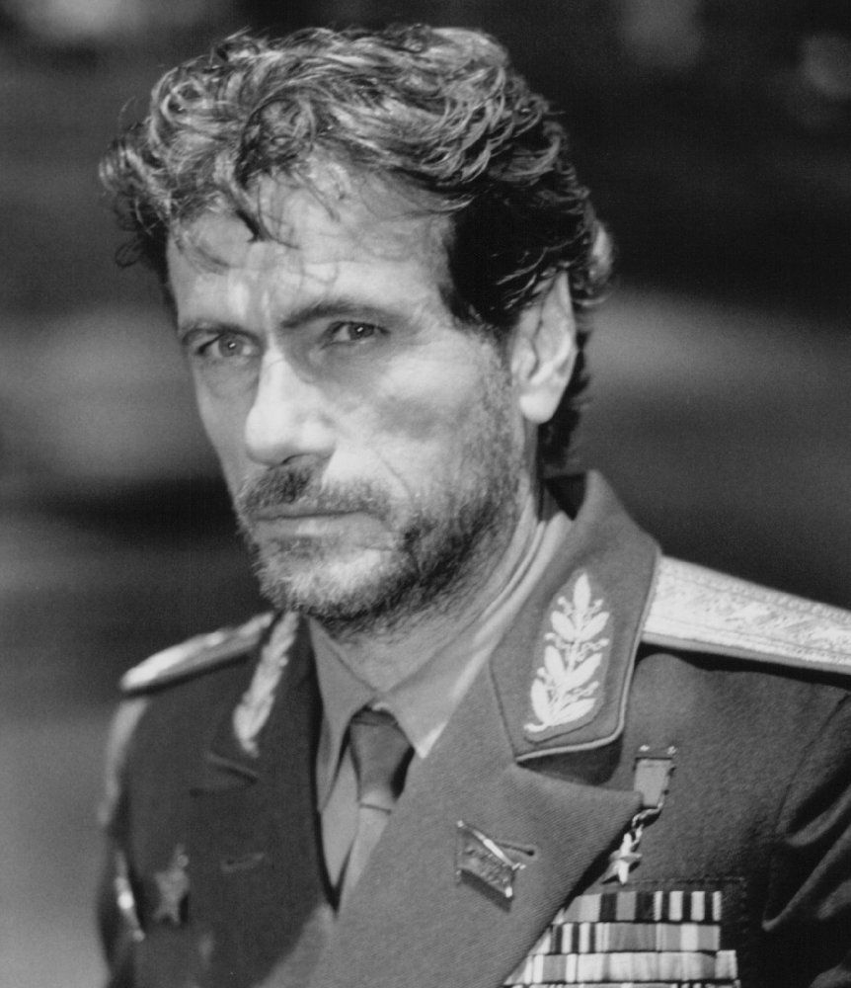

Led by General Igor Petrov, a **former Soviet military agent,** who operated from 1983-1991, the SRP successfully **assassinated Nursultan Nazarbayev, the President of Kazakhstan,** on 8th August, 2017. This was followed by 3 months of civil war and unrest during which the SPR wrest control of the executive and **established a dictatorship under Petrov.** Throughout 2018, all who opposed Petrov were brutally executed (death tolls are estimated at 800,000+) and a state of emergency was declared which gave the new government absolute power.

However, on 4th April, 2019, a **Navy SEAL operation** infiltrated the Kazakh Palace and **captured General Petrov,** who was tried for crimes against humanity and sentenced to death. He now awaits execution, which is scheduled on 13th June. He was succeeded by his second-in-command, Romanov Topalov.

Though his genocidal actions have been placed before the Security Council, Resolution S/RES/2388 (2018), ‘Violations of International Humanitarian Law in Kazakhstan’ **was vetoed by Russia,** who claimed that military intervention violated Article 2(7) of the UN Charter, the right to internal sovereignty.

**Reports have ascertained that the SPR has built-up its military capacity, with its Air Force consisting of a small but elite fleet of 50-120 MiG-29 and a dozen Sukhoi jets, over and above other reconnaissance and support aircraft.** The SPR carries out its operations through an internal agency which is highly secretive.

**4. Section C: Foreign and Military Policy of the NATO**

**4.1. Military Policy**

NATO is arguably the largest and the most powerful military alliance in the world. Approximately 20,000 military personnel are engaged in NATO missions around the world, which involves regions like Kosovo, Afghanistan, the Middle East (which involves countering the deadly ISIS), the African Continent, and Ukraine among others. Increasing military actions of Russia along NATO’s borders continues to make the Euro-Atlantic security environment more unpredictable and unstable. **Delegates are expected to be familiar with the ongoing missions of the NATO and the possible areas in which it can operate.**

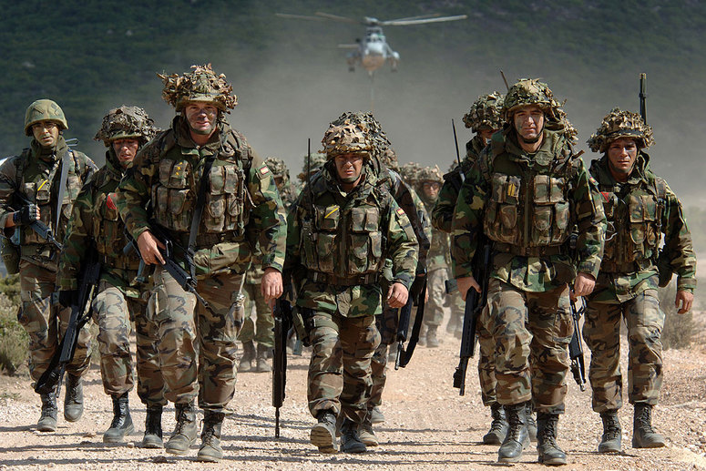

NATO has its main headquarters in Brussels, and military headquarters in Mons, Belgium. It has a Military Committee (MC), which is the senior military authority in NATO and the oldest permanent body in NATO after the North Atlantic Council, both having been formed months after the Alliance came into being. It is the primary source of military advice to NATO’s civilian decision-making bodies – the North Atlantic Council and the Nuclear Planning Group.[8] The committee plays an essential role in not only assisting the development of strategic policy and concepts, but also establishes a link between the political decision-making process and the military structure of the NATO. In times of crises, the Military Committee advises the Council of the military situation and its implications, and makes recommendations on the use of military force, the implementation of contingency plans and the development of appropriate rules of engagement.

The Military Committee also has an executive body, called the International Military Staff (IMS). IMS is responsible for providing strategic and military advice and staff support for the Military Committee. IMS also ensures that NATO decisions and policies on military matters are implemented by the appropriate NATO military bodies.[9]

**4.2. Role of the US**

NATO's fundamental goal is to safeguard the freedom and security of its allies by political and military means. NATO remains the principal security instrument of the transatlantic community and expression of its common democratic values. It is the practical means through which the security of North America and Europe are permanently tied together. NATO enlargement has furthered the U.S. goal of a Europe whole, free, and at peace.[10]

The United States pays just over 22 percent of NATO’s common funding for infrastructure and collectively owned equipment. It can be considered as the chief military actor and driving force of the NATO. Throughout history, Western Europe and their North American allies have played a key role in preventing the Soviet expansion towards eastern Europe and aided in reconstructing their economy. Russia’s continued destabilizing pattern of military activities and aggressive rhetoric, remains a major concern for NATO.

However, remarks regarding NATO by the United States President, Donald J. Trump, has caught many eyeballs. His statements regarding the principle of collective self-defence and questions regarding the relevance of NATO have raised many concerns. The friendly Trump-Putin relationship has also caused fear that Mr Trump’s rhetoric could spell the end of basic elements of transatlantic security doctrine and cause further Ukraine-style interventions by Russia in other Eastern-European countries. Besides, NATO members are obliged to spend at least 2 percent of their GDP on defense, but only certain countries like the United States, the United Kingdom, Greece, Estonia and Poland meet the target. During one of his presidential campaigns, Mr. Trump stated that if countries don’t make the payment to NATO that they are supposed to make, the US under Donald Trump wouldn’t necessarily uphold its end of the bargain. This statement indeed created a stir around the world. However, since his election victory, Mr. Trump has appeared to soften on his stand regarding the defence contribution, which has undeniably relieved the NATO allies. The White House has also issued statements assuring the world community that there shouldn’t be any mistake about the United States of America’s commitments to the NATO and the US would always remain dedicated to the Alliance. 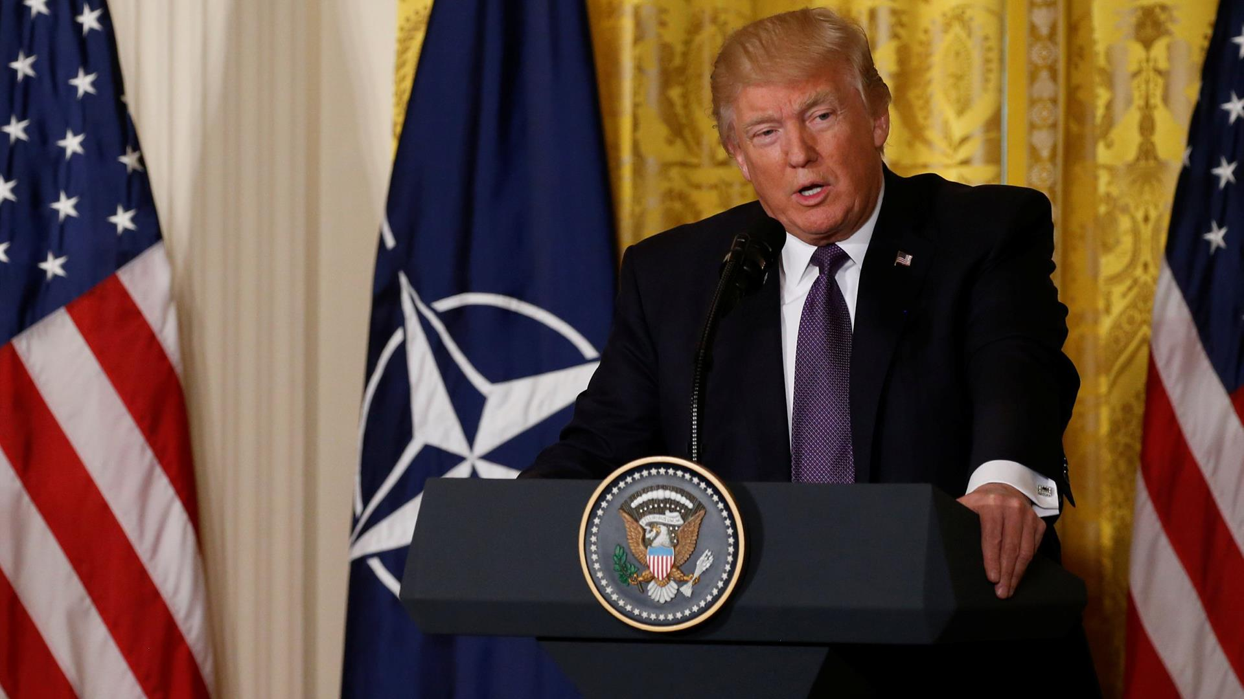

**4.2.1. DEFCON**

Developed by the Joint Chiefs of Staff and the Unified and Specified Combatant Commands Levels, DEFCON is a scale which is used by the US Armed Forces. It stands for Defense Readiness Condition and measures the alertness of the US Defense Forces. There are 5 DEFCON levels and five DEFCON alert level colors. Level 1 is the maximum and is represented by the colour red, is the highest alert state and is used in situations of global severity like nuclear war. Level 5 is represented by the colour blue and is the lowest and safest status. It is the minimum level and is used in normal peacetime situations. The levels can be classified as follows:

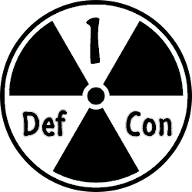

**Level 1:** DEFCON level 1, also called "Cocked Pistol" or "white alert" is a maximum defense readiness condition created in 1959 by the joint chiefs of staff that means nuclear war is imminent. The department of defense and United States Armed Forces have never before raised the defcon levels status to level 1 in the history of the United States since the status was implemented.

**Level 2:** "Fast Pace" or defcon level 2 is a "red alert" status and means we are at the next step to a nuclear war. With condition two, the United States Armed Forces are ready and prepared to ship out in 6 hours or less. DEFCON Level 2 has been reached only once for the SAC, or strategic air command during the Cuban Missile Crisis in October 26, 1962. During that time the United States Armed Forces remained at level three.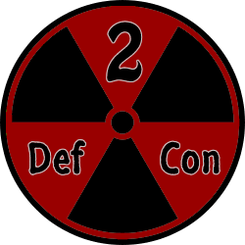

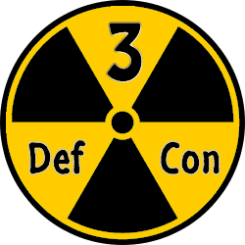

**Level 3:** DEFCON 3, also called "Round House" or "yellow alert" is an increase in alertness and readiness. With level 3 the air force is in a state of readiness so that they can deploy and mobilize within 15 minutes time. The meaning behind 3 is similar to that of a yellow "Caution" sign.

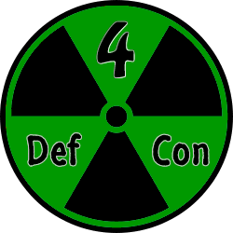

**Level 4:** DEFCON level 4, also called "Double Take" or "green alert" is an increase in intel gathering and strengthening of security protocols. 4 readiness is considered "Above Normal Readiness". This is just one level lower than "Normal readiness" with the military on green alert status. The US moved to DEFCON 4 after the 9/11 attacks and is still on DEFCON 4.

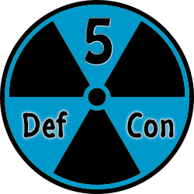

**Level 5:** DEFCON 5, also called "Fade Out" or "blue alert" is the lowest or normal state of readiness. Level five means implies a complete and total state of peace.

**4.2.2. NORAD**

The North American Aerospace Defense Command (NORAD) is a bi-national organization between the US and Canada. Its mission is to conduct aerospace warning, aerospace control and maritime warning in the defense of North America.

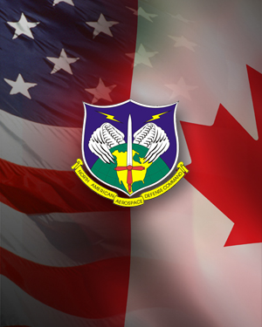

**Aerospace warning:** it detects, validates, and warns of attack against North America (whether by aircraft, missiles, or space vehicles, through mutual support arrangements with other commands).

**Aerospace control:** ensures air sovereignty and air defense of the airspace of Canada and the United States.

**Maritime Warning:** The renewal of the NORAD Agreement in May 2006 added a maritime warning mission. It entails a shared awareness and understanding of the activities conducted in U.S. and Canadian maritime approaches, maritime areas and internal waterways.

NORAD responds to the threats and issues warnings. It works in collaboration with security, home defence and law-enforcement partners. The structure of NORAD continually changes to adapt to the changing world. NORAD’s commander is responsible to the US President, as well as the Canadian Prime Minister.

**4.3 Tension in the Crimean Peninsula:**

The Crimean Peninsula has always been an unstable and volatile region within Ukraine, and its desire for autonomy within the larger context of its relation with Ukraine has sparked conflict within the Eastern Ukrainian region in recent years. Crimea, until 2014, was under the territorial mandate of Ukraine. However, due to insurgency and propaganda campaigns, the region had a large chunk of pro-Russian sympathisers who wished to break away from the unstable Ukrainian Government.

This was recognised by Putin who saw this as an opportunity to integrate Crimea into Russia and expand its territorial borders. In a bold and decisive military action taken by Moscow, insurgents infiltrated the Ukrainian borders in February 2014. Pro-Russian protests were held rampantly. Three days later, Russian Special Forces seized the Supreme Council and set up strategic commands in several important cities, notably Sevastopol. A referendum was held to determine the fate of the territory, however, this was denounced and not officially recognized by the UN as it was ‘lacking any validity’ and hence ‘nullified the legal basis’ to accede Crimea to Russia.

Despite this, on 17 March, following the official announcement of the referendum results, the Supreme Council of Crimea declared the formal independence of the Republic of Crimea, comprising the territories of both the Autonomous Republic of Crimea and the city of Sevastopol, which was granted special status within the breakaway republic.

Hence, two conflicting viewpoints can be raised while debating this issue: the first, of sovereignty and territorial integrity, the second, of self-determination. Delegates are encouraged to further research into this topic as a wide range of perspectives must be understood to flourish in committee. Besides, NATO is weary that tension as a result of this may manifest itself in other location.

**5. Section D: What’s Special About Crisis Committees?**

**5.1. An Introduction:**

Most MUN Conferences across major circuits have a varied mixtures of conventional and crisis committees. The two kinds differ primarily in their size and manner in which they tend to function. Neither one is more distinguished than the other and both enjoy a unique status in the educational experience they impart.

Conventional committees, as the name suggests, are traditional, **large bodies that assemble periodically to discuss issues of global significance.** While committee can tend to get loquacious and overly academic at times, it can be greatly enjoyable to immerse oneself in intellectual debate and produce tangible paperwork at the end.

A few examples of conventional committees and their agendas:

1. UN General Assembly (6): *The Legality Of Humanitarian Intervention in Syria With Respect To The Principle Of Sovereignty.*
2. UN Human Rights Committee: Reviewing the Rights of Women and Children involved in Conflict.
3. UNFCCC: Reviewing the Kyoto Protocol with emphasis on Carbon Tax on Developing Nations.
4. IMF: Restructuring Payment of Intergovernmental Debt for Sustainable Development
5. Lok Sabha, Budget Session: Budget for FY 2017-18.

crisis.jpg

In contrast, crisis committees are **smaller, more cohesive and engaging bodies** that instead of deliberating on political or ethical matters, attempt to solve urgent crises that may arise. Some consider such committees to not be truly relevant but a mere escape from the reality of current human affairs. However, these committees are often better than their counterparts: being an effective ‘crisis delegate’ requires **admirable leadership skills**, **creative and analytical thought processes** and an i**mmense base of knowledge** on *any and every topic,* however obscure.

At the most fundamental level, a crisis committee can never have an agenda. Crises are dynamic and ever-changing and delegates must cope with whatever is thrown at them. An intelligence body (for example, the KGB) may be investigating war lords in Mexico and be informed the next moment that there is a ‘mole’ who is leaking crucial information to a drug cartel in Puerto Rico.

Sample Crisis Committees with Agendas:

1. Churchill’s War Cabinet: *Blitzkrieg on London*
2. The Emperor’s Royal Council: *The Revolt of 1857*
3. Lehman Brothers’ Board of Directors: *The Wall St. Crash*
4. CIA: *Agenda Classified*
5. Emperor Hirohito’s Cabinet: *Preventing Operation Downfall*
6. The Nazi Reich: *Achieving Anschluss*

**5.2. Modes of Documentation:**

Conventional committees primarily frame resolutions: long, verbose documents with superfluous language that provide detailed solutions to not-so-crucial problems.

If one were to frame draft resolutions for crisis committees, it would end in utter failure; framing such paperwork takes days and new crisis updates arrive by the minute. Consequently, crisis committees use a plethora of different devices, which are discussed hereunder, to simultaneously address the problem at hand and further the crisis arc.

**5.2.1. Committee Directives:**

At its very core, a directive is an order. An order to any public or state-controlled entity to perform a specific set of actions. The vast majority of all paperwork will be done through committee directives, which is based on the principle of collective and consensual actions as an organisation. When a crisis update is announced, it is typically followed by 15-20 minutes of substantive, formal debate in the form of moderated caucuses and a period of unmoderated (informal) caucus, during which committee as a whole is to arrive at a consensus (or not, there are often conflicting directives) and produce tangible directives at its conclusion. It is then followed by voting, during which it is either passed and put into effect or failed. As an Executive Board, we strongly recommend using committee directives as the main form of taking action as it encourages collaborative effort rather than resorting to covert action through individual directives. **All directives introduced in committee must be passed unanimously; even the negative vote of one member-state shall fail the directive.** We believe that this is in the spirit of fraternity and collective action that the NATO espouses. Keeping in mind the aforementioned principle, **any member-state who provides a negative vote will be required to provide a verbal statement justifying the same.** This may be followed by a maximum of one follow-up question from the Executive Board *if deemed necessary*.

**5.2.2. Individual Directives:**

These work in the same fashion as committee directives, but they are secretive actions taken by that country alone. They are **not revealed to committee** unless desired and are **passed solely at the discretion of the Executive Board.** Used effectively, such directives are very powerful tools to leverage favour of the committee towards a particular goal while furthering one’s personal interest.

An instance of an individual directive at an actual MUN conference involved a naval chief in Hitler’s war cabinet passing a directive to destroy one of his own battleships off the coast of Danzig (a very important port stripped from the Germans and internationalised by the Treaty of Versailles) and make it appear as if it were bombed by the Polish in a time of peace. Thus, he misled committee into thinking that the Polish waged war on Germany, sanctioned funds for expanding the navy (again illegalised by the Treaty) and attained a casus belli for waging war.

A good directive has:

* A **specific addressee who must be under your direct command;**
* A **specific** set of actions or orders (be as detailed as possible) to be undertaken; and
* A few lines describing the **expected goals and outcomes** of said actions.

There is no set format or word limit, although bullet points would be highly appreciated in the interest of neatness and separating the multiple actions you may choose to execute through your directives. **One effective directive containing a list of actions is preferred to a barrage of successive directives as it allows us to process your actions that much more effectively.**

**A sample individual directive**[11]:

|  |
| --- |
| **Operation Nautilus**  TO: Admiral of the 7th Fleet, Thomas Fitzwallace   * Under my authority as Commander, USPACOM, move the following ships from the US base in Yokosuka, Japan to 15 nautical miles NE of the Straits of Malacca in the South China Sea:   + 2 Arleigh Burke Class Destroyers: *Fitzgerald* and *Stethern*   + 1 Virginia Class Submarine: *USS Texas (SSN-775)*   + 1 Nimitz Class Aircraft Carrier: *George Washington* * They will be moved on the 15th of September, 2015 at 21:30 (GMT+9) * They will patrol the area and protect oil trade to the Philippines, a close US ally   Through these measures, I expect all piracy against commercial and military vessels in the area to cease, and any pirates to be captured and reported to me.  *Commander Harper, US Pacific Command*  **5.2.3. Communiques:**  These are **interpersonal communications** which may be between the delegate and the entire lexicon of crisis characters: everyone who is both within and outside the committee room. You can communicate with the Queen of England, an informant or even your mother. Your job through all chits is to logically convince us of why you are doing what you want to do. These notes are an **excellent means of obtaining information** on a particular topic from the horse’s mouth, especially if such information is not easily available in books and state departments.  **5.2.4. Press Statements:**  Contrary to popular belief, releasing press statements is a very effective way to express the committee’s policies on a particular topic. It is not necessary to be completely honest and true while making statements, and being able to **manipulate what the rest of the world hears is instrumental** in being able to **pile pressure on an external aggressor** and **attain political sympathy**.  **A press statement must be made multilaterally, i.e, it is made by committee as a whole.** If a delegate wants to make a statement regarding his/her nation’s stance, it will take the **form of a Presidential Statement from a particular country.**  **5.3. Tips and Suggestions**  **Pre-conference:**   1. Research: this activity is at the very core of any conference. Applying a systematic and thorough approach to investigating each and every facet of the agenda or crisis is the only way to be equipped enough to tackle the various hurdles crisis committees hurl at delegates. Being well-versed with military doctrines and foreign policy of not only your own but other’s delegations as well shall allow you to direct and table debate in a manner that is beneficial to NATO and showcases your depth of understanding to all in the crisis room. That being said, to quote Portia, Act 1 Scene 2…here are a following effective methods to work towards the goal of enlightenment:    1. Parallel Research: Let’s say you’re assigned the role of a counterintelligence officer in the KGB. Now, there’s no readily available information available on this role. What do you do? You could sulk and wait to ask your chairs so you can start research a day late. However, a smart delegate would identify that the role of intelligence personnel isn’t likely to vary much across continents and so a quick glance at the CIA website’s description of a counterintelligence officer offers an easy solution by providing a generous description of the role.    2. Referring to Declassified Documents: consider the problem of trying to quantify the weapons stockpile of a particular nation, say, Israel. Trying to search for accurate data on the internet is utterly futile as such information is highly sensitive and classified. However, one may recognize that there has been little militarization in the past 50 years considering that it has been a period of relative peace. Thus, by reading declassified documents about Israeli military in the 1970s or during the Yom Kippur and Six Day War would provide a rough estimate of its strength today. To be more accurate, one could observe a general trend of stockpiles of all nations across the globe and recalibrate the data accordingly.    3. Using official websites: news articles and other improper sources generally provide skewed information on many topics. Hence, we advise that you largely restrict yourself to conducting research on official state and governmental department’s websites. While they may conceal information, what they ensure is that everything they said can be taken to be true (unless otherwise falsified with conclusive proof) in committee.   2. Envision: Consider the SRP, which is a purely fictional organization. It would for obvious reasons be impossible to research them in detail. Hence, it is advisable to consider the motives and objectives of the party by putting yourself in the shoes of General Petrov. What would he want to accomplish? Why? How does this affect the frail network of relations that exist between nations? Could there be other third-party actors who covertly dictate the actions of the SRP?  3. Network: Connect and discuss ideas with not only Executive Board but also other delegates. Don’t hesitate in clarifying any apprehensions you may have had whilst researching.  **During Conference:**  1. Floor Time: often perceived as too difficult or boring an activity to participate in, debate is quintessential to our daily lives and indeed, more so in MUN. We practice debate each and every living moment when we consider watching one movie over another or weigh the consequences of cheating on a test with the implications of failure. **To debate effectively does not imply the ubiquitous utilization of superfluous prose and flawless grammar, but rather, providing the stony face of sheer logic.** A statement to justify a particular stance must convince using rational thinking rather than attempting to recite the Communist Manifesto with the motive of appearing high and mighty before committee.  2. Other Time: The time when one’s time on the floor is over is even more valuable than the time that preceded it. A plethora of different activities must occur concurrently for a delegate to be even remotely successful in committee. To subdivide one’s organs to perform multiple functions is a crucial albeit impossible necessity*. In a crisis committee, one should always delegate one ear to listen to speeches being made, another to carry out backroom negotiations with a fellow delegate; one hand should raise a placard to indicate one’s willingness to speak, another must be tasked with drafting directives and communiques to excess; eyes identify other hubbub that occurs in the room and the brain provides itself as a command center for the next masterplan*. To lapse back to reality, trying to perform more than one activity in a given time frame is an excellent skill to possess. |
|  |

**6. References, Points to Note and Further Reading**

**6.1 Points to Note**

**Contact Us!**

Chairperson: Vedant Chandra

[me@vedantchandra.com](mailto:me@vedantchandra.com)

Vice-Chairperson: Preetika Pahwa

[preetika.pahwa@gmail.com](mailto:preetika.pahwa@gmail.com)

Crisis Director: Raman Thadani

[rthadani9@gmail.com](mailto:rthadani9@gmail.com)

**6.2 References**

1. <http://www.nato.int/nato-welcome/index.html>
2. <http://www.history.com/topics/cold-war/formation-of-nato-and-warsaw-pact>
3. <http://www.msz.gov.pl/en/foreign_policy/nato_2016/nato/history_of_nato/>
4. [http://www.statecraft.org.uk/research/understanding-nato’s-structure-and-function](http://www.statecraft.org.uk/research/understanding-nato%E2%80%99s-structure-and-function)
5. <http://www.nato.int/cps/en/natohq/topics_49137.htm>
6. <http://www.nato.int/cps/en/natolive/official_texts_17120.htm?selectedLocale=en>
7. <http://www.nato.int/docu/posters/timeline-eng.pdf>
8. <http://www.nato.int/nato-welcome/files/checklist_en.pdf> (Please view this checklist. It will serve as a great summary about the NATO)
9. <http://www.reuters.com/article/us-nato-summit-history-idUSL3151283520080331>
10. <http://www.nato.int/ims/docu/mc411-1-e.htm>
11. <http://www.nato.int/nato_static/assets/pdf/stock_publications/20120822_nato_treaty_en_light_2009.pdf> (North Atlantic Treaty and Accession Protocols)
12. <http://www.nato.int/cps/ro/natohq/topics_49187.htm>
13. <https://www.state.gov/p/eur/rt/nato/>
14. <http://www.nato.int/cps/en/natohq/topics_64557.htm>?
15. <http://bestdelegate.com/how-to-write-a-crisis-directive/>
16. <http://www.nato.int/cps/tr/natohq/topics_49633.htm>
17. <http://www.usanato.army.mil>
18. <https://nato.usmission.gov>
19. <https://www.whitehouse.gov/the-press-office/2017/05/25/remarks-president-trump-nato-unveiling-article-5-and-berlin-wall>
20. <http://www.defconlevel.com>
21. [http://www.defconlevel.com/levels.php#](http://www.defconlevel.com/levels.php)
22. <http://www.norad.mil/About-NORAD/>

1. http://www.history.com/topics/cold-war/formation-of-nato-and-warsaw-pact
2. http://www.nato.int/nato-welcome/index.html
3. http://www.statecraft.org.uk/research/understanding-nato’s-structure-and-function
4. http://www.nato.int/cps/en/natohq/topics_49137.htm
5. http://www.msz.gov.pl/en/foreign_policy/nato_2016/nato/history_of_nato/
6. http://www.nato.int/cps/en/natohq/topics_89597.htm
7. http://www.nato.int/cps/ro/natohq/topics_49187.htm
8. http://www.nato.int/cps/tr/natohq/topics_49633.htm
9. http://www.nato.int/cps/en/natohq/topics_64557.htm?
10. https://www.state.gov/p/eur/rt/nato/
11. http://bestdelegate.com/how-to-write-a-crisis-directive/