Background Guide
General Assembly
Legal Sixth Committee

Criminal Accountability of UN Peacekeepers
Dear Delegates,
Welcome to Shri MUN 2017, and especially, welcome to the General Assembly! We are looking forward to two days of intense debate on this unique agenda. This guide is necessary for you to read as it will give direction to your further research as well as the debate that will follow. At the conference, we will be looking for your interpretations and use of facts rather than simply your ability to recite figures, so research well enough to indulge in original debate, along with your substantive knowledge and contribution to consensus building. We will also be looking at your lobbying and negotiation skills and your accuracy to your country's foreign policy.
We would also encourage you to send in as many points of orders/information; however, you should not only rely on written work in the committee.
We would urge all the delegates to go beyond this Guide as it is only an introduction to the agenda. All the delegates should be well versed in the Peacekeeping forces and should be able to answer the following questions:
a) Who do the peacekeepers work for and who deploys them?
b) What laws govern the conflicted areas, especially those areas where peacekeepers are deployed?
c) What are tribunals?
d) Who prosecutes the peacekeepers? To who are the liable to?
e) What are the international laws pertaining to peacekeepers?
f) Have they been previously tried at the International Criminal Court
This background guide is divided into two parts a committee introduction and a comprehensive review of the agenda. The former is a General Introduction to the Sixth Committee of the General Assembly and the latter is a background on our agenda. We have also included the sections: ‘Issues to Address’ and ‘Documents to Consider’ to help streamline your research process. For the sake of clarity we have enlisted the parameters of judgment for various awards of the committee.
Our main aim for the committee is for all the delegates to come to a consensus on this volatile matter through debates and ultimately pass a resolution as a solution for the problem at hand.
Please feel free to email any of us if you have doubts. Make sure you read the background guide well and research beyond this basic framework. We are looking forward to two days of intellectually stimulating debate that will leave us all richer with knowledge.
Best of luck!
Anirudh Bhashyam, Chairperson
bhashyam.anirudh@gmail.com
Pankhuri Prasad, Chairperson
pankhuri.prasad11@gmail.com
Saranya Das Sharma, Vice Chairperson
saranya.dassharma@gmail.com
Yuvraj Duggal, Crisis Director
duggalyuvraj12@gmail.com

JUDGMENT CRITERIA FOR DELEGATES
(The following points are in no particular order)
- Research Analysis/Method
- Initiative in committee
- Factual accuracy
- Contribution to consensus building
- Participation in Unmoderated and moderated Caucuses’
- Knowledge, accuracy, and use of country foreign policy
- Paperwork such as resolutions, working papers etc.
- Points of information/order.

CONTENTS
- General Introduction
- Criminal Accountability of UN Peacekeeping Forces
- Introduction
- Department Of Peacekeeping Operations (DPKO)
- International Criminal Law
- Accountability
- Zeid Report
- Jurisdictional Gaps
- Types Of Misconduct
- Issues To Address
- Documents To Consider
- Case Study
- References
- Resolutions and Reports

I. GENERAL INTRODUCTION
COMMITTEE
The sixth committee constitutes the main legal body of the UN General Assembly. The committee, of course, discusses matters of legal nature and is structured much like the other committees based on universal membership.

The Committee not only drafts new dispositions of international law, but also offers interpretations of existing international legislation, makes recommendations for Members to implement international regulations through national law and considers legal issues affecting the United Nations Secretariat, its different bodies and their activities.

MANDATE AND INSTRUMENTS
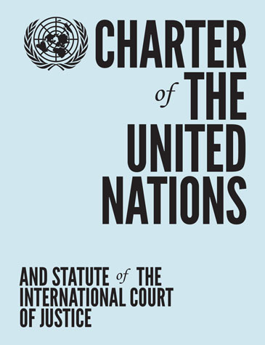
The mandate of the Committee is contained in article 13a of the UN Charter:
“The General Assembly shall initiate studies and make recommendations for the purpose of:
a) Promoting international cooperation in the political field and encouraging the progressive development of international law and its codification;
b) Promoting international cooperation in the economic, social, cultural, educational, and health fields, and assisting in the realization of human rights and fundamental freedoms for all without distinction as to race, sex, language, or religion.”
The Sixth Committee, however, only proposes resolutions to the General Assembly to adopt.

SESSIONS
The committee commenced its 72nd session on the 11th of November, 2016. The topics being addressed are “International Terrorism,” “Rule of Law,” “Administration of Justice,” “Universal Jurisdiction.”
II. CRIMINAL ACCOUNTABILITY OF UN PEACEKEEPING FORCES

1. INTRODUCTION
United Nations peacekeeping missions constitute one of the largest public faces of the UN system as a whole; the work and actions of the men and women deployed on such missions reflect the legitimacy of the UN. Chapter VI, VII and VIII provide the UN Security Council with powers to maintain peace, resolve conflict etc. including the establishment of a UN peacekeeping Operation.
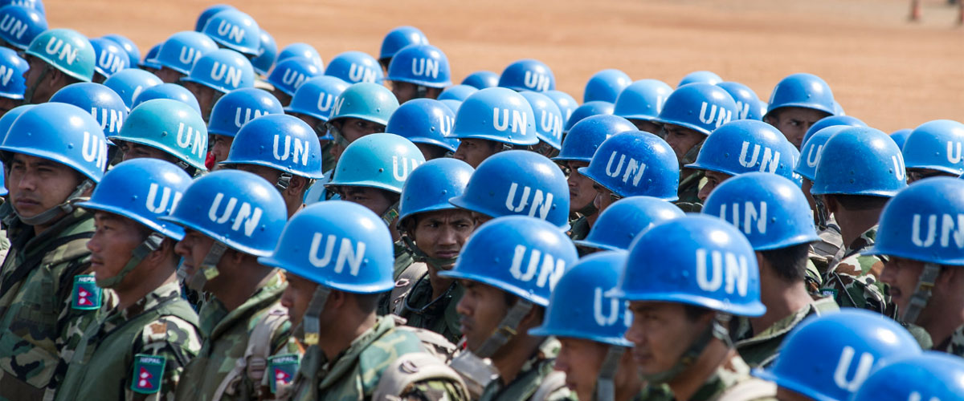
United Nations peacekeeping was conceived soon after the establishment of the Organization to monitor ceasefires and peace agreements, first through the use of unarmed observers and later (1956) supplemented with armed battalions. By 1960, with the establishment of the United Nations Operation in the Congo, United Nations peacekeeping evolved dramatically from monitoring to providing a 7 A/59/710 substantial array of technical assistance to a Government desperately in need of support. This form of multidimensional peacekeeping was groundbreaking for the Organization. But such was the enormity of the effort expended by the United Nations in the Congo that it was not until 1989, with the formation of the United Nations Transition Assistance Group in Namibia, that this type of peacekeeping was practiced again. From that point on, the majority of United Nations peacekeeping operations mounted by the Security Council have undertaken a variety of tasks beyond monitoring.

The founders of the United Nations did not intend that the privileges and immunities of officials (staff have the status of officials) and experts on mission (civilian police and military observers have the status of experts on mission) constitute a shield from national criminal prosecution for crimes committed in a State hosting a United Nations operation. However the absence of a functioning judicial system in some peacekeeping locations means that it is not feasible to waive immunity in those jurisdictions. As a result, the prosecution of staff or experts on mission for crimes committed in such a State depends on whether the State of nationality of the suspect has conferred extraterritorial jurisdiction on its courts to take such action and whether it can, in the circumstances of the case, effectively take such action. But this would tend to be the exception rather than the rule.

The United Nations involves itself in four major endeavours to establish and maintain peace. They are:

Conflict prevention
Conflict prevention involves diplomatic measures to avert the escalation of intra-state or inter-state tensions and disputes into violent conflict.
It includes early warning, information gathering and a careful analysis of the factors driving the conflict.
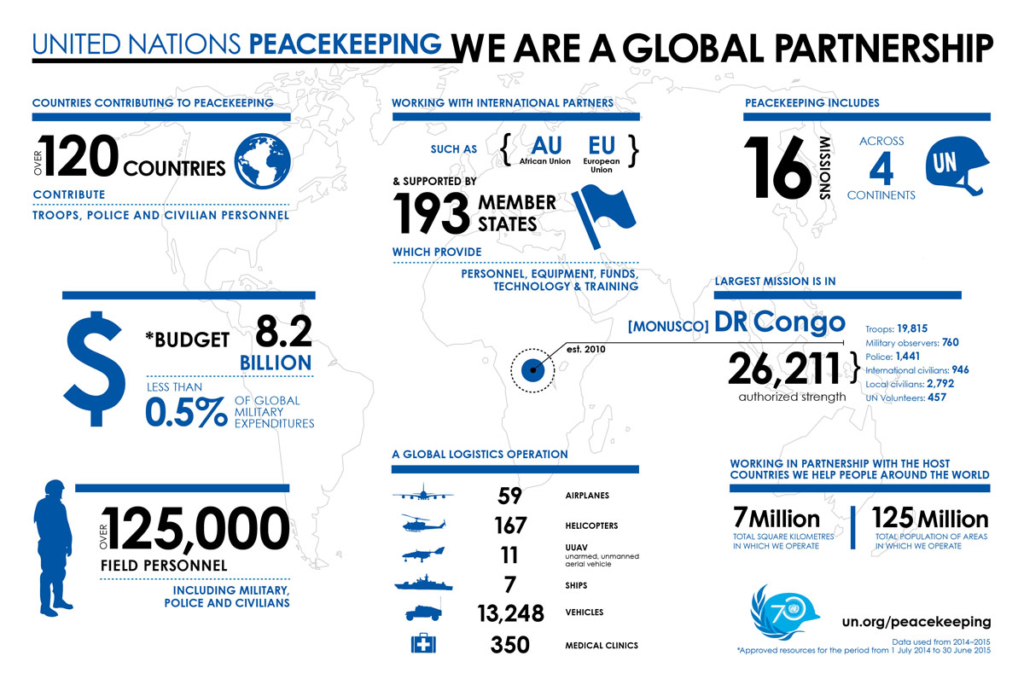
Peacemaking
Peacemaking includes measures to address conflicts in progress and usually
involves diplomatic action to bring hostile parties to a negotiated agreement.
The UN Secretary-General may exercise his or her “good offices” to facilitate the resolution of the conflict. Peacemakers may also be envoys, governments, and groups of states, regional organizations or the United Nations.

Peace enforcement
Peace enforcement involves the application of a range of coercive measures, including the use of military force. It requires the explicit authorization of the Security Council.
It is used to restore international peace and security in situations where the Security Council has decided to act in the face of a threat to the peace, breach of the peace or act of aggression. The Council may utilize, where appropriate, regional organizations and agencies for enforcement action under its authority and in accordance with the UN Charter.

Peacebuilding
Peacebuilding aims to reduce the risk of lapsing or relapsing into conflict by strengthening national capacities at all levels for conflict management, and to lay the foundation for sustainable peace and development. It is a complex, long-term process of creating the necessary conditions for sustainable peace. Peacebuilding measures address core issues that affect the functioning of society and the State, and seek to enhance the capacity of the State to effectively and legitimately carry out its core functions.

The number of United Nations peacekeeping and peacebuilding missions around the world has surged in this decade, as has the number of personnel deployed in such missions. The vast majority of these individuals are committed and professional in their efforts to bring peace to nations scarred by conflict. Nonetheless, accounts of misconduct by personnel in UN peace support operations (PSOs) have surfaced periodically over the years; especially when demand for operations has spiked and operations have involved increasingly challenging, complex tasks in substantially lawless environments.

2. DEPARTMENT OF PEACEKEEPING OPERATIONS (DPKO)
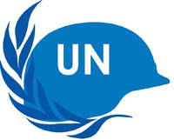
DPKO provides political and executive direction to UN Peacekeeping operations around the world and maintains contact with the Security Council, troop and financial contributors, and parties to the conflict in the implementation of Security Council mandates. The Department works to integrate the efforts of UN, governmental and non-governmental entities in the context of peacekeeping operations. DPKO also provides guidance and support on military, police, mine action and other relevant issues to other UN political and peacebuilding missions.

DPKO traces its roots to 1948 with the creation of the first UN peacekeeping operation: UN Truce Supervision Organization (UNTSO) and UN Military Observer Group in India and Pakistan (UNMOGIP). It was not until 1992 that the DPKO was officially created when Boutros Boutros-Ghali took office as Secretary-General of the United Nations.
The DPKO has four major offices:

Office of Operations

Office of the Rule of Law and Security Institutions

Office of Military Affairs

Policy Evaluation and Training Division

PREVIOUS ALLEGATIONS
In the 1990s, there was a major rise in the number of peacekeeping operations authorized by the UN Security Council, in part due to the increased harmony between the United States and the Soviet Union/Russian Federation. Enhanced collaboration, coupled with a fundamental shift in the nature of conflicts from interstate conflict to intra-state conflict, drove a new trend in peacekeeping missions. Specifically, complex multidimensional enterprises that sought to implement cohesive peace agreements and assist in creating the necessary foundation for sustainable peace. From 1989 to 1994, the UN Security Council authorized twenty new missions, bringing the number of deployed peacekeepers from 11,000 to 75,000. However, many of these missions were not considered successful, as the warring factions violated peace agreements, or where the peacekeepers did not have the adequate resources and support to successfully carry out their mandates. As a result, the UN started a number of investigations into the role that peacekeepers played in highly volatile situations, and began the process of reform.
The first case relating to the criminality of peacekeeping personnel was reported in the 1999 when a UN Peacekeeping Operation was deployed to Kosovo. The UN’s investigation revealed that numerous officials were involved in the trafficking of up to 2000 female sex slaves.

The misconduct issue came to a boil in 2004 when several dozen members of the UN mission in the Democratic Republic of the Congo (MONUC) were accused of serious sexual exploitation and/or abuse (SEA) against members of the local population. MONUC earned particular notoriety for stories of staff members using pitifully small lures—one US dollar, two eggs, a glass of milk—to induce sexual favors. But such problems extended to other operations as well, including those in Haiti and Liberia. The Secretary-General’s June 2008 report on SEA in UN missions observed, moreover, that “reports from other organizations suggest chronic underreporting of allegations of SEA.
Serious misconduct by even one peacekeeper is unacceptable given their responsibilities and obligations, and the distressing stories of abuse emerging from peacekeeping missions have led to better training, better reporting, and improved investigatory capacity.

3. INTERNATIONAL CRIMINAL LAW
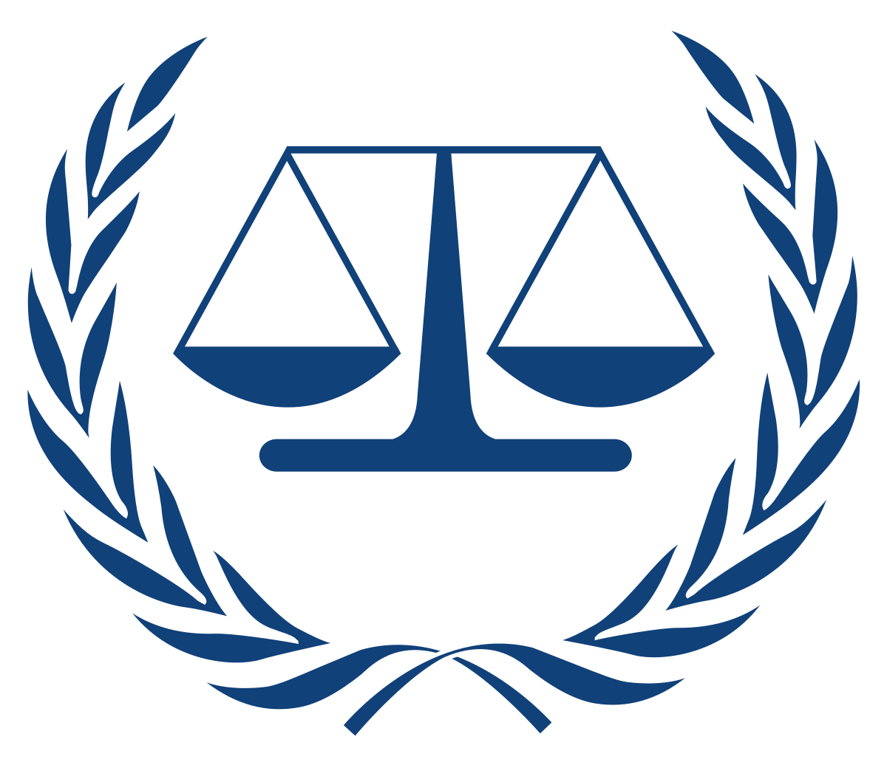
International Criminal Law (ICL) is a relatively new and constantly developing branch of public international law. By criminalizing gross violations of human rights and serious violations of international humanitarian law, it exposes perpetrators of such conduct to criminal liability. ICL provides criminal sanctions that apply to all perpetrators, including those at the highest political and military levels who engage in international crime.

International crime may be defined as a
crime against international law. This is said to occur when three conditions are satisfied:
If there is a violation of a criminal norm derived out of an international treaty and other international customary law which is binding on individuals;
- The crime shows the characteristic of a crime that is punishable under the International law; and
- The treaty establishes a liability for the act done, and this must be binding on majority of countries.

There are many examples relating to international crime including war-crimes, crimes against humanity, crimes against peace, genocide and other crimes, under international law, such as drug trafficking, money laundering, terrorism etc.

4. ACCOUNTABILITY
Early efforts to establish a permanent international criminal court did not get very far owing to Cold War tensions. After several decades of hardly any progress, the breakthrough came in 1993 and 1994 respectively, with the establishment of the two ad hoc criminal tribunals for the former Yugoslavia (ICTY) and Rwanda (ICTR).

Both tribunals were created by the Security Council which, treading on previously untested ground, drew on its Chapter VII powers to establish judicial organs with which all UN member States are legally obliged to cooperate. The tribunals, simply put, showed that international adjudicatory mechanisms were not only necessary but also possible, thus paving the way for the adoption, several years later, of a treaty for the world’s first permanent International Criminal Court (ICC).

International Criminal Court (ICC)
The ICC investigates and prosecutes under four categories of international crime: genocide, crimes against humanity, war crimes and crimes of aggression. There are five crimes that the ICC has opened investigations on: Northern Uganda, the Democratic Republic of Congo, the Central African Republic, Sudan and the Republic of Kenya. The ICC has the authority to take cases in countries that are members of the court, are self-referred or if the case has been referred by the Security Council. However, the court operates independently from the UN.

Although a court of international law already existed through the International Court of Justice (ICJ), the ICJ’s works on settling disputes between member states of the UN and cannot take action on individuals. Moreover, the judgements of the ICJ are advisory in nature and must be enforced by the UNSC. The ICC can initiate prosecutions without UN action or referral.

Other Judicial Bodies
The establishment of the ad hoc Tribunals paved the way not only for negotiations on the ICC treaty, but also, at least indirectly, made it possible to pursue work on the creation of three other judicial bodies: the first dealing with crimes committed two and a half decades ago in Cambodia; the second dealing with crimes committed in Sierra Leone not that long ago; and the third dealing with crimes committed before and after the UN-administered referendum on the independence of East Timor in 1999.

Parsing through SEA allegations is difficult for several reasons. Allegations against soldiers have received the most press attention perhaps in part because military personnel outnumber other personnel in UN operations by a wide margin. In 2005, UN reports suggested that the proportion of UN staff implicated in abuse was higher than the proportion of military personnel, but in subsequent years, allegations against military mission personnel were proportionally much higher than those against other mission personnel. Publicly available data are also somewhat inconsistent from year to year and leave issues about the disposition of some cases unanswered. The Department of Peacekeeping Operations (DPKO) and the Department of Field Support (DFS) also have one reporting chain for allegations of misconduct not related to SEA, while the independent OIOS has another reporting chain, specifically for SEA.

5. ZEID REPORT
In 2005, then special advisor to the Secretary-General of the United Nations, Prince Zeid Ra’ad Zeid al-Hussein submitted a report titled: “A comprehensive strategy to eliminate future sexual exploitation and abuse in United Nations peacekeeping operations”

This report outlines in much detail the of the problem of sexual exploitation and abuse in peacekeeping operations, Rules regarding this problem laid down in the United Nations, Investigations conducted, organizational, managerial and command accountability, Individual disciplinary, financial and criminal accountability, Criminal accountability of military members of national contingents, Criminal accountability of United Nations staff and experts on mission.
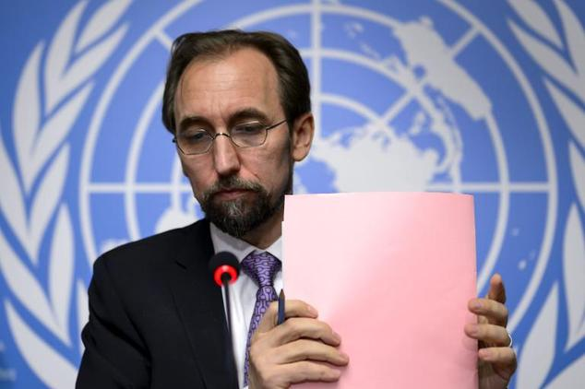
Prince Zeid Ra’ad Zeid al-Hussein

6. JURISDICTIONAL GAPS
Jurisdiction refers to the official power to make legal decisions and judgements. A jurisdictional gap arises when the deciding court lacks jurisdiction over certain legal questions. It has been claimed that a “jurisdictional gap” and the absence of a regulated process for dealing with crimes committed by United Nations officials and experts on missions hinders the ability of the Organization to hold its personnel accountable. A Group of Legal Experts on the matter had recommended the development of a new convention to address jurisdiction and other matters. A convention would enable States to establish jurisdiction in circumstances as broad as possible. It would also provide certainty about who was subject to the exercise of such jurisdiction and the crimes covered. The convention should require States to exercise jurisdiction when the alleged offender is one of their nationals or is in their territory and not being extradited. The convention should also require States to consider establishing jurisdiction when the victim is one of their nationals or, in the case both of alleged offenders or victims who are stateless persons, when the habitual residence is on their territory.

7. TYPES OF MISCONDUCT
Misconduct is classified into two broad categories, according to the relative seriousness of the contravention and risk to the Organization.
SEA constitutes one type of what the United Nations defines as “Category I” misconduct. Consistent with the Staff Rules and Regulations, the Secretary-General has “broad discretion in determining what constitutes serious misconduct and in imposing disciplinary measures” in instances where misconduct is substantiated.
Category I  SERIOUS | Category II  ROUTINE
- Serious/complex fraud or criminal activity  - sexual exploitation and abuse  - prohibited conduct by senior staff members  - conflict of interest  - gross mismanagement  - waste of substantial resources  - risk of loss of life to staff or to others  - complex proactive investigations aimed at studying and reducing risk to life and/or United Nations property  - entitlement fraud  - procurement violations  - substantial violations of United Nations regulations, rules or administrative issuances | - personnel matters  - traffic related inquiries  - simple thefts  - contract disputes  - office management disputes  - basic misuse of equipment or staff  - prohibited conduct by staff  - basic mismanagement issues

8. ISSUES TO ADDRESS
Several areas require attention in order to improve prospects criminal responsibility among persons serving in UN peace operations.
Some of the problems are:
- The mandate language and its potential effects on the scope of functional immunity.
- The need for better integrated reporting capacity and independent investigative capacity with regard to alleged serious criminal misconduct; the UN’s approach to “ordinary” crime.
- The need to ensure a level playing field for UN personnel with respect to criminal justice.
- Responsibility of host states and the establishment of a transparent legal system both internationally and within a state to ensure justice.

9. DOCUMENTS TO CONSIDER
- 59/300. Comprehensive review of a strategy to eliminate future sexual exploitation and abuse in United Nations peacekeeping operations, 22June 20055 , (whereby the Group of Legal Experts was established)
- 60/263. Comprehensive review of the whole question of peacekeeping operations in all their aspects, 6 June 2006.
- Resolution 61/29. Criminal accountability of United Nations officials and experts on mission, 4 December 20067 , (whereby the Ad Hoc Committee on criminal accountability of United Nations officials and experts on mission was established)
- Resolutions 62/63.9 , 63/119.10, 64/110.11, 65/20.12, 66/93.13, 67/88.14
- 62/214. Comprehensive Strategy on Assistance and Support to Victims of Sexual Exploitation and Abuse by United Nations Staff and Related Personnel, 21 December 2007
- Resolution 69/114. Criminal accountability of United Nations officials and experts on mission, 10December 2014 - Convention on the Privileges and Immunities of the United Nations, 13 February 1946

Brahimi report. In March 2000, the Secretary-General appointed the Panel on United Nations Peace Operations to assess the shortcomings of the then existing system and to make specific and realistic recommendations for change. The panel was composed of individuals experienced in conflict prevention, peacekeeping and peacebuilding. The result, known as the “Brahimi Report”, after Lakhdar Brahimi, the Chair of the Panel, called for:

Renewed political commitment on the part of Member States;

Significant institutional change;

Increased financial support.

The Panel noted that in order to be effective, UN peacekeeping operations must be properly resourced and equipped, and operate under clear, credible and achievable mandates.

Peacekeeping policy and strategy reform. Following the Brahimi report, UN Member States and the UN Secretariat continued major reform efforts, including through:

“Capstone Doctrine” (2008), outlining the most important principles and guidelines for UN peacekeepers in the field;

Peace operations 2010 (2006), containing the reform strategy of the Department of Peacekeeping Operations (DPKO);

2005 World Summit [A/RES/60/1] , establishing the Peacebuilding Commission;

High-level Panel on Threats, Challenges and Change [A/59/565] , setting out a broad framework for collective security for the new century.

III. CASE STUDY:

THE UNITED NATIONS ORGANISATION STABILISATION MISSION IN THE DEMOCRATIC REPUBLIC OF THE CONGO
MONUSCO is a peacekeeping mission which replaced the original commission The United Nations Organization Mission in Democratic Republic of the Congo (MONUC) on 1 July 2010. The original mandate of the mission was established by Security Council resolution 1925 on 28 May to reflect the new phase reached in the country. It was authorized to use all necessary means to carry out its mandate relating, among other things, to the protection of civilians, humanitarian personnel and human rights defenders under imminent threat of physical violence and to support the Government of the DRC in its stabilization and peace consolidation efforts.
The Council decided then that MONUSCO would comprise, in addition to the appropriate civilian, judiciary and correction components, a maximum of 19,815 military personnel, 760 military observers, 391 police personnel and 1,050 members of formed police units. Future reconfigurations of MONUSCO would be determined as the situation evolved on the ground, including: the completion of ongoing military operations in North and South Kivu as well as Orientale provinces; improved Government capacity to protect the population effectively; and the consolidation of State authority throughout the territory. The mandate of MONUSCO was further detailed in resolution 2053 adopted by the Security Council on 27 June 2012.
On 28 March 2013, recurrent waves of conflict in eastern DRC threatening the overall stability and development of the country and wider Great Lakes region led the Security Council to create (by its resolution 2098) a specialized “intervention brigade” for an initial period of one year and within the authorized MONUSCO troop ceiling of 19,815. It would consist of three infantry battalions, one artillery and one special force and reconnaissance company and operate under direct command of the MONUSCO Force Commander, with the responsibility of neutralizing armed groups and the objective of contributing to reducing the threat posed by armed groups to state authority and civilian security in eastern DRC and to make space for stabilization activities.
The Council also decided that MONUSCO shall strengthen the presence of its military, police and civilian components in eastern DRC and reduce, to the fullest extent possible for the implementation of its mandate, its presence in areas not affected by conflict in particular Kinshasa and in western DRC.
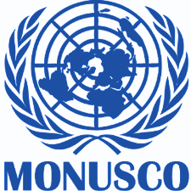
On 28 March 2014, the Security Council, by its resolution 2147, extended the mandate of MONUSCO until 31 March 2015 and decided that the renewed mandate would also include MONUSCO’s Intervention Brigade — “on an exceptional basis and without creating a precedent or any prejudice” — within the authorized troop ceiling of 19,815 military personnel, 760 military observers and staff officers, 391 police personnel and 1,050 formed police units.
At the same time, the Council noted the need for a clear exit strategy and decided that the Mission’s further reconfigurations and mandates should be based on the evolving situation and progress towards several objectives set out in accordance with its three priorities — protecting civilians, stabilizing the country, and supporting implementation of the Peace, Security and Cooperation Framework for the Democratic Republic of the Congo and the region.

REFERENCES
- http://www.un.org/en/peacekeeping/operations/peace.shtml
- http://thehague.thimun.org/images/THEHAGUE/THIMUN_The_Hague_2015/GA-Checked1.pdf
- https://www.theguardian.com/profile/owenbowcott
- http://www.un.org/en/peacekeeping/issues/cdu.shtml
- https://www.files.ethz.ch/isn/102719/Improving_Criminal_Accountability_June2009.pdf
- http://gimun.org/wp-content/uploads/Guides_GIMUN_2016_Legal_EN.pdf
- http://scholarship.law.cornell.edu/cgi/viewcontent.cgi?article=1058&context=facpub
- https://www.diakonia.se/globalassets/documents/ihl/ihl-resources-center/international-crimes-and-accountability-a-beginners-introduction-to-the-duty-to-investigate-prosecute-and-punish.pdf
- https://www.icrc.org/eng/assets/files/other/013-034_pejic.pdf
- http://www.un.org/en/ga/search/view_doc.asp?symbol=A/59/710
- http://eu-un.europa.eu/eu-statement-united-nations-6th-committee-criminal-accountability-un-officials-experts-mission/
- https://www.un.org/press/en/2008/gal3342.doc.htm
- https://oios.un.org/resources/2015/01/OIOS_ID_Manual2015.pdf
- http://www.un.org/en/peacekeeping/missions/monusco/mandate.shtml
- http://legal.un.org/criminalaccountability/ 9

RESOLUTIONS AND REPORTS
- http://www.un.org/en/ga/search/view_doc.asp?symbol=A/RES/59/300 6
- http://www.un.org/en/ga/search/view_doc.asp?symbol=A/RES/60/263 7
- http://www.un.org/en/ga/search/view_doc.asp?symbol=A/RES/61/29 8
- http://www.un.org/en/ga/search/view_doc.asp?symbol=A/RES/62/63
- http://www.un.org/en/ga/search/view_doc.asp?symbol=A/RES/63/119
- http://www.un.org/en/ga/search/view_doc.asp?symbol=A/RES/64/110
- http://www.un.org/en/ga/search/view_doc.asp?symbol=A/RES/65/20
- http://www.un.org/en/ga/search/view_doc.asp?symbol=A/RES/66/93
- http://www.un.org/en/ga/search/view_doc.asp?symbol=A/RES/67/88
- http://www.un.org/en/ga/search/view_doc.asp?symbol=A/RES/69/114
- http://www.un.org/en/ethics/pdf/convention.pdf
- https://www.globalpolicy.org/images/pdfs/zeidrep.pdf
- http://www.un.org/en/ga/search/view_doc.asp?symbol=A/55/305
- http://pbpu.unlb.org/pbps/Library/Capstone_Doctrine_ENG.pdf
- http://www.un.org/en/peacekeeping/documents/po2010.pdf
- http://www.un.org/en/ga/search/view_doc.asp?symbol=A/RES/60/1
- http://www.un.org/en/ga/search/view_doc.asp?symbol=A/59/565

Refer to this link for an organisational flowchart on peacekeeping (http://www.un.org/en/peacekeeping/documents/dpkodfs_org_chart.pdf)
http://www.icty.org/en/documents/statute-tribunal
http://unictr.unmict.org/en/documents/statute-and-creation
Links in ’Resolutions and Reports’

